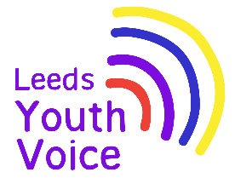
Schools White Paper:
What young people think about the proposals

The Voice, Influence and Change Team asked young people what they think about new ideas for schools.

The Government wants to:
- Change how schools support children
- Help children with SEND get better support
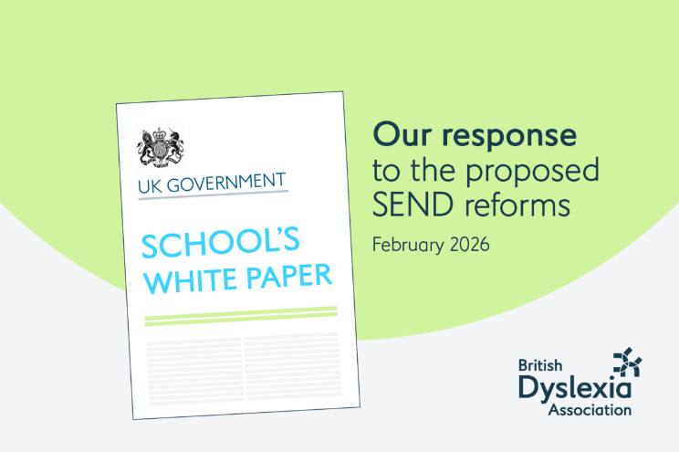
These are just ideas, and the voice of young people will share what happens next.

55 young people from 5 settings took part in the consultation.
- Leeds SEND Youth Council.
- The Bridge, East SILC.
- Ralph Thoresby School.
- Future Steps, Broomfield South SILC.
- Coop Academy.

What helps me in school?
Young people said they need:

Help with learning  - Help with reading, writing and lessons  - Teachers to explain things clearly | Help in class  - Extra time  - Support from teachers or teaching assistants  - Small groups | Feeling calm and safe  - Quiet spaces  - Breaks when needed  - Time to calm down
Being understood  - Staff who listen  - Help with feelings  - Someone to talk to | Health and daily support  - Help with medical needs  - Help with everyday things | Future skills  - Help with life skills  - Jobs and college choices

What did young people think of the proposed changes?

👍 Liked  - Teachers getting SEND training  - More help in school  - Inclusion bases (extra support in school)  - More children getting help earlier | 🤔 Not sure about  - How will it all work?  - What will change in school?  - What are “layers of support”?  - How will new plans work? | 😟 Worries  - Not getting enough help  - Losing EHCP support  - Losing specialist schools  - Things not being fair  - Being treated the same as others with different needs

The Main Ideas

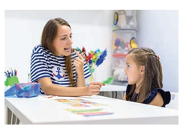 | Inclusion Bases  A space in school for extra help  👍 Good: More support in school  😟 Worry: Losing specialist schools
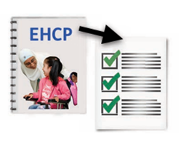 | EHCP Changes  Plans for children who need a lot of help  👍 Good: More children might get help  😟 Worry: Some children might lose support
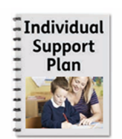 | Individual Support Plans (ISP)  A plan to help you in school  👍 Good: Help sooner  🤔 Not sure: Will schools follow it?
 | Layers of support  Different levels of help  👍 Good: Could be fairer  🤔 Not sure: Hard to understand
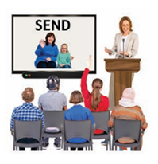 | SEND Training  Training for teachers  ✅ MOST POPULAR!  👉 Helps staff understand you better
 | What matters most  - “Listen to us”  - “Treat everyone fairly”  - “Explain things clearly”  - “Don’t take our support away”


Final Message
Young people said:
- Change is needed
- But it must be clear, fair and safe
- And young people must be heard

What happens next…
A detailed report has been shared nationally with the Government and will be considered as part of the consultation process for the Schools White Paper.

