
Inclusion Advisory Team Service
February 2026
Opportunity
In Autumn 2025, we carried out a parent carer survey to help us better understand the experiences of children and young people with SEND who attend mainstream settings.

The survey was open for four weeks on the Local Offer and shared widely through the Parent Carer Forum. In total, 148 parents and carers responded.

Purpose of the IMP:
- Outline the provision and support that mainstream settings should be able to provide for all children and young people including those with Special Educational Needs and/or disabilities (SEND) attending an educational setting in Leeds.
- Help settings consider what extra support might be relevant for all children and young people who are not progressing at the rate they would expect.
- Help parents understand what settings will be doing.

Intended impact:
- Increased teacher confidence in supporting learners with SEND.
- Improved parental confidence in mainstream schools.
- Resources distributed more effectively
Outcome
Following feedback from the parents and cares who attended the event, the team will be introducing the following to the parent carer section of the Inclusive Mainstream Practice:
- Videos to provide accessible overview.
- Provide information about pathways of support.
- Promote the IMP to families.
Obligation
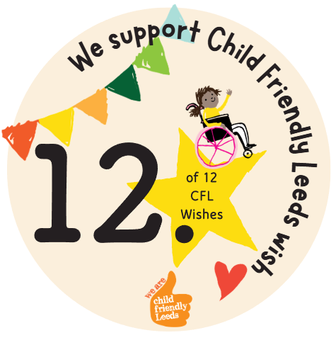

We support Child Friendly Leeds wish

Opening
15 parents and carers attended the Parent Carer Support Group Network event on Monday 23rd February 2026 at Pudsey Civic Hall.

The event was an opportunity for the Inclusion Advisory Team to share the new Inclusive Mainstream Practice (IMP) with parents and carers and get their feedback.



