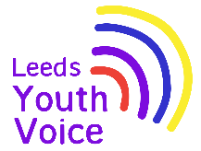
Harewood House
April 2026

Opportunity
The insights gained from the survey and focus groups were subsequently utilised to inform design of the initial draft of the map.
Outcome
Harewood House are now in the process of sharing the outline design for the map with Leeds City Council, and we will then proceed with next steps to get the sign installed. As this map is part of our overall planning conditions for the playground, it is taking slightly longer than it usually would to have the sign installed, as it is part of a bigger process.
Obligation
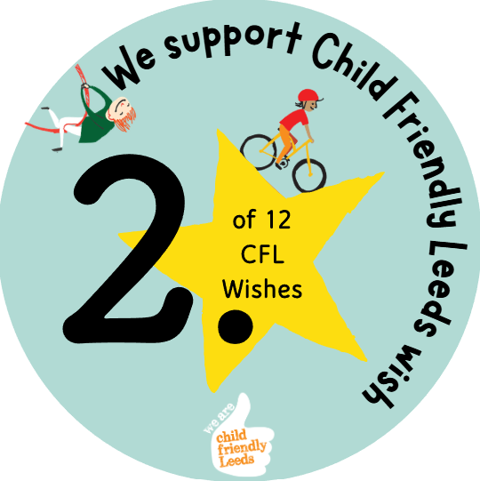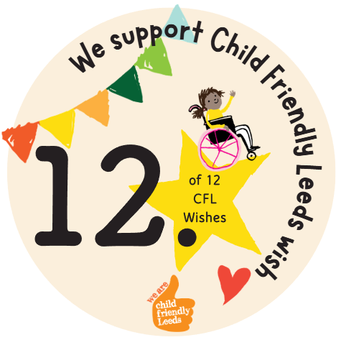

We support Child Friendly Leeds wish

Opening
Harewood House wanted young people, parents and carers to share their views on how play signage can be improved at Harewood House.

In September 2025; 7 participants complete the online survey to share their views about play signage.

In addition to the survey, Harewood House ran a number of focus groups with local community groups, which looked at further layout questions.

