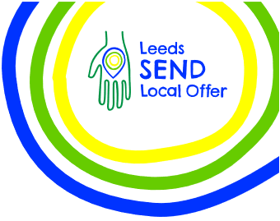
Leeds Local Offer Live 2026
Wednesday 25th March 2026
10am till 3pm at Pudsey Civic Hall

Leeds Local Offer Live is an annual marketplace event that provides parents, carers and professionals the opportunity to find out about SEND services in Leeds.

The 2026 event took place on Wednesday 25th March 2026, 10am till 3pm at Pudsey Civic Hall.

Services
52 services booked a stall at the event, with 47 attending on the day.

Information about all services in attendance can be found on the Leeds Local Offer website at www.leedslocaloffer.org.uk

- Childrens Centre Family Services  - Health and Wellbeing Service  - 0-19 Henry  - MindMate Support Team  - Leeds Mencap  - Leeds SEND parent carers  - Leeds Survivor Led Crisis Service  - Irwin Mitchell  - SNAPS  - NEUROSTARS  - Refresh Carers  - SENSE children and young people’s service  - Sensory World  - ZigZag Leeds Autism Support  - Little Hiccups  - Sunshine and Smiles  - Leeds Parent Carer Forum  - Leeds Local Offer  - Scope  - Through the Maze  - Carers Leeds  - Leeds Sensory Services BID  - Welfare Rights  - Independent Travel Training | - West Yorkshire Combined Authority  - Transitions Team, Leeds City Council  - Family Hubs  - Employment and Skills  - ND Information Hub  - Children’s Speech and Language Therapy  - Paediatric Audiologist  - ICAN  - Chatterbug  - Health Facilitation Team  - Aireborough Supported Activities Scheme (ASAS)  - Leeds Weekend Care Association  - Northern Ballet  - MathsCity  - People Matters  - RISE Learning Hub Yorkshire  - Pivot Academy  - Learning Inclusion  - Leeds City College  - Leeds Libraries  - Purple Patch Arts  - SENDIASS  - Lighthouse Futures Trust
All services who attended were given an evaluation form to share their feedback about the event, 16 services completed and returned their evaluation forms.

Services rated the overall event as good / very good and found it a great opportunity to network with other professionals and share information about their services with families.

“one of the best organised events, and looking forward to next year’s event”

“it was awesome”

Suggestions for improvements:
- City centre location.
- Room felt quite echoey.
- Location away from door as it is was quite windy.
- Access to a water fountain.
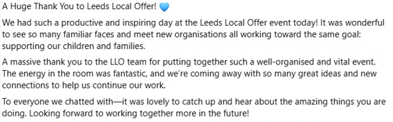

Attendees
The event was promoted to families via:
- the Leeds Local Offer facebook group including paid promotion,
- Leeds Parent Carer Forum,
- parent carer support group facebook pages,
- schools (primary, secondary and specialist),
- Child Friendly Leeds social media channels,
- The Leeds Local Offer network.
- Services booked to have a stall at the event.

112 parents / carers, 68 professionals and 3 young people attended the event, totaling 183 in attendance.

The majority of attendees found out about the event either via the email, facebook or school.

Email | 26% |  | Support Groups | 4%
Facebook | 23% |  | Work | 4%
School | 14% |  | College | 3%
Online | 12% |  | Children’s Centre | 2%
Leeds Local Offer | 6% |  | NHS | 2%
Cluster | 5% |  | Instagram | 1%

Overall attendees rated the event as very good and valued the range of services available to speak to on the day.

Feedback from attendees:

“Great event”
“Well organised, lots of information and nice to talk to actual people”
“Keep doing this event, it is so useful”
“Found the information from Lighthouse Futures Trust really useful”
“So many services I didn’t know about”
“Information for under 5’s was really useful”
“Great to see Local Authority and Health services in the same place”.

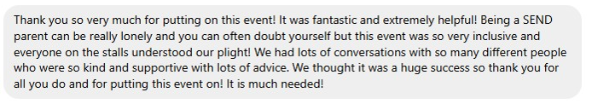

Improvements for future events
- Services missing - Short Breaks, Family Fund, ADHD specific services and SEN FE providers.
- Publicise the event more.
- Room was quite loud and echoey.
- Information for adults – SEND doesn’t stop at 25 years old!!

