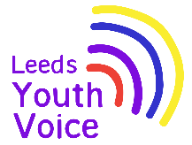
Neurodiversity Information Hub (NHS)
February 2026
Opportunity
A brief video demonstration of the information hub resource was shared with the group, followed by the young people answering the 4 below questions in groups.
- Have you seen the ND Info Hub website before? If so, did you find it helpful?
- What would you find helpful to have on a website about neurodivergence (e.g. autism, ADHD, dyslexia, learning disability)
- How would you like the information to be shared? (e.g. writing, pictures, videos, audio, diagrams)
- Where would you look for this information? (e.g. school, online, social media, books, AI).

You said:
It was good to see that many of the suggested information and formats already exist on the current resource.

Themes for developments: No-one had used the resource before, so better access is needed. Social media was a core source of information, so we need to utilise social media more. Many suggested more videos, interactive activities, diagrams, colour filter changes and more colourful, engaging designs. More ND voices are also needed. ‘How to handle it/deal with it’ was also a highlighted need that we need to explore in more detail.
Outcome
The information has been collated and will be shared with the commissioners, website developers/ designers and the clinicians involved.

This will help guide the team on prioritising and funding future developments.

Developments will be organised into small changes that can be completed as a priority, followed by larger changes that will need more commissioner involvement.

We are very grateful for your voices and ideas and will do our best to make the changes you want!
Obligation
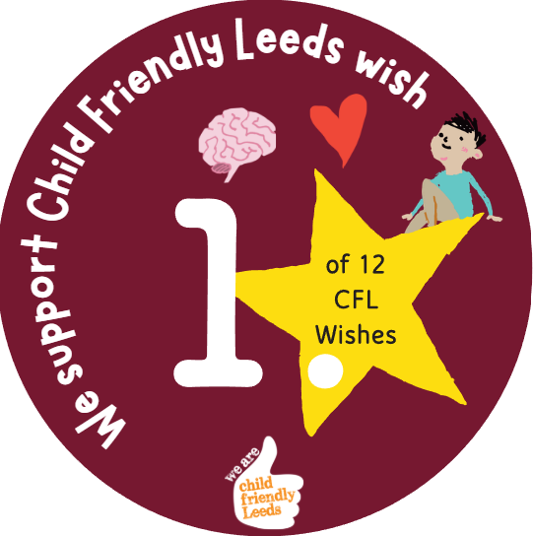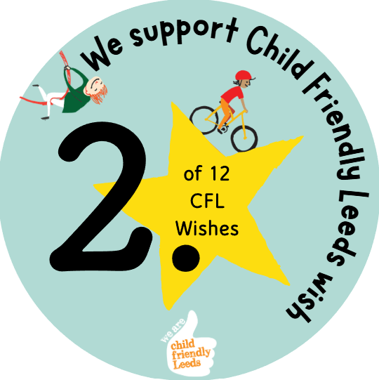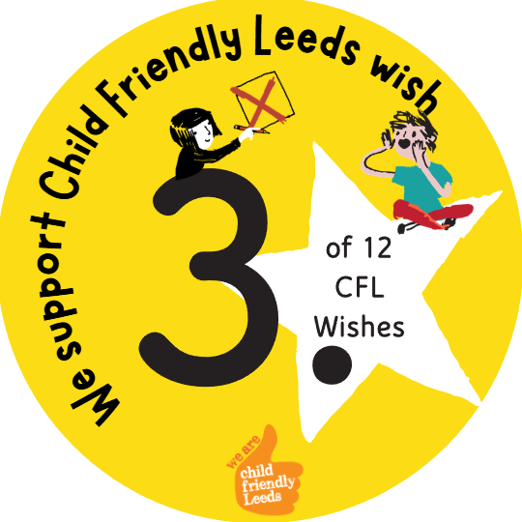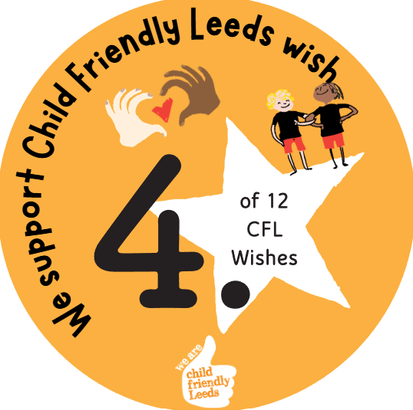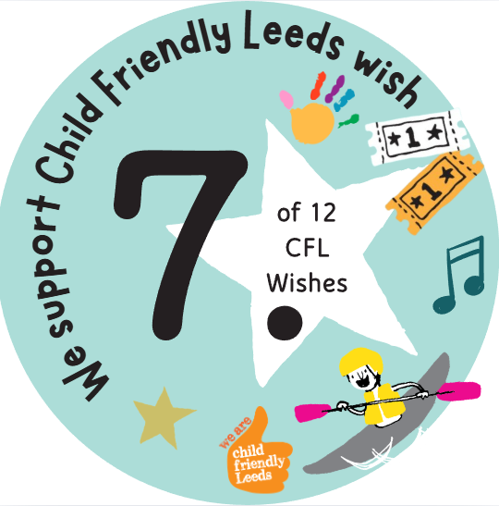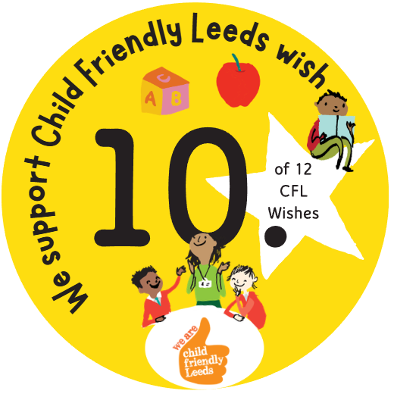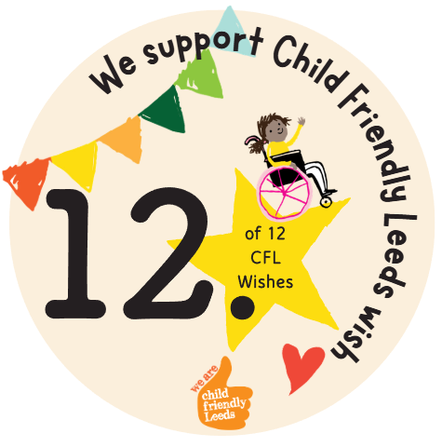

We support Child Friendly Leeds wish

Opening
The Neurodiversity Information Hub digital resource was taken to consultation at the SEND Summit on 11th February 2026 at Leeds Civic Hall.
The resource being shared with 52 young people from 11 specialist educational settings across the city for their views and feedback.

