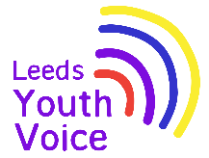
Health and Wellbeing Services
February 2026

Opportunity
We had prepared some multi choice questions, around SEMH, for pupils to answer.

These could be multiple responses or a single response.

Outcome
The information will be used to complement the rest of the My Health My School Survey results collected from across the SEND survey results across the city.

This will inform our current and future offer to SILC settings and schools e.g training opportunities for staff, training for pupils and resources we share.
Obligation
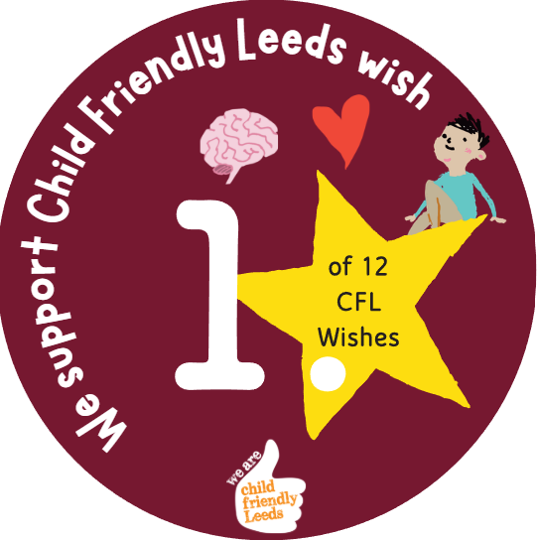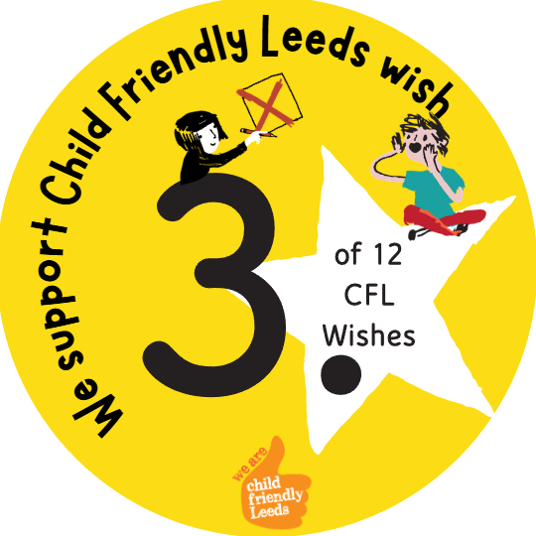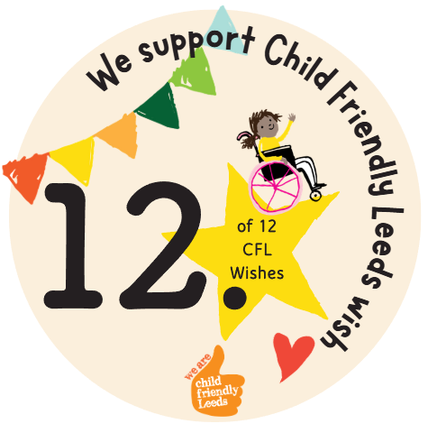

We support Child Friendly Leeds wish

Opening
Consultation stall with students at the SEND Summit on the 11th February 2206.

Consulted with 20 students around social, emotional wellbeing and mental health.

