
One minute guide

Early Years SEND Home Visiting Service
January 2026
What is the Early Years SEND Home Visiting Service?
It is a pre-school home visiting educational and support service for young children with special educational needs and disability (SEND). The aim is to help parents / carers to become teachers of their own children in their own homes. The service uses small steps teaching to help children learn.
The Leeds Early Years’ SEND Home Visiting service is registered with the National Portage Association (NPA).

What is the Early Years SEND Home Visiting Service Offer?
Following an assessment, the family may be offered home visits or signposting to other relevant services. The offer is based upon the child and family’s needs. If home visits would be beneficial, families are allocated an Early Years’ Home Visitor.
Home visit support will be offered for a maximum of up to 6 months, the frequency dependent upon progress and ongoing need. There are three main elements to each home visit: structured teaching, child-led play, and family focus. Each visit lasts for around an hour.
The Home Visitor works with the family to find out what the child ‘can do’, identify goals, and plan activities towards the next steps in the child’s development.

Which children and families does the Early Years SEND Home Visiting service work with?
Requests to the service can be made in the following circumstances:
- The child is aged between 0 to 2½ years of age.
- The child presents with 50% delay in 2 or more areas of development: cognition and learning; social communication and interaction; speech and language; social, emotional and mental health; physical; nursing/medical; hearing; vision; and sensory.
- The family are living in the Leeds local authority area.

How are requests made to the Early Years SEND Home Visiting service?
There are three ways to make a request to the service, dependent upon who is making the request:
- Parents / carers can make a request by completing a Leeds Early Years’ SEND Home Visiting Service Request form. Also, any practitioner working with the family can make a request as long as they have the agreement of the child’s parents / carers.
- All health professionals should complete a Health to Education Notification (HEN), ensuring they have the agreement of the child’s parents / carers.
- If the child is attending an early years’ setting and the family agree home-based support should be requested, the SENCo (SEN Coordinator) in the setting should complete a One SEND Services Request for support. The form should be completed on the understanding that the service offer will be home-based.

A member of the Early Years’ SEND Home Visiting service will contact parents / carers to inform them of the outcome of the request and the service offer for them and their child.

What other support does the service offer?
The Early Years’ SEND Home Visiting service works closely with other professionals involved with the child, for example, ICAN (Integrated Children’s Additional Needs) teams, Health Visitors, and teams from across the Learning Inclusion service.

Key contacts
To contact a member of the Early Years’ SEND Home Visiting service, please telephone 0113 3782888 or email SEND@Leeds.gov.uk

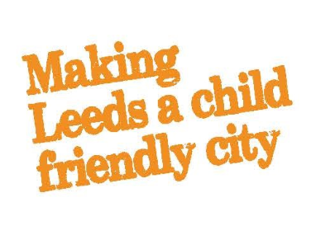
One minute guides homepage

