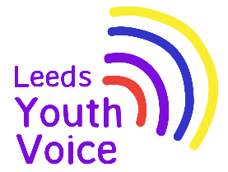
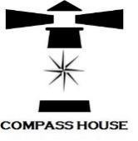
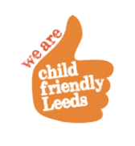
Compass House Christmas 2025
Summary Report

Background
In 2017; 102 students from across specialist learning provisions in Leeds took part in the Mark Your Mark ballot (largest youth consultation in the UK). From the ten issues the students collectively voted that a Curriculum to Prepare us for Life as the top issue for them. Students tookover the SEND Partnership Board (previously Complex Needs Partnership Board) in November 2017 and spoke to the board about what a curriculum for life means to them and how they would like valuable work experience.

The Compass House project was set up in 2018. Staff from specialist schools across Leeds supported students to come together to plan and open their very own pop up shop for one week during the month of December in Kirkgate Market. Students made all decisions about the shop (known as Compass House) including making all the products to sell.

Due to the success of the project in 2018, this has now become an annual event.

Compass House December 2025


Supported by the Voice, Influence and Change Team; students from East SILC, West SILC, Broomfield South SILC, Green Meadows Academy, The Lighthouse School, Coop Academy Brierley and Future Horizons met monthly, September to December 2025, to plan the opening of the 2025 Compass House pop up shop.

Students made all the decisions about promotion, products to sell and shop décor.

The Compass House pop up shop opened Monday 8th to Friday 12th December 2025, 10am till 2pm in Kirkgate Market.

Leeds Kirkgate Market provided the unit free of charge for the week.


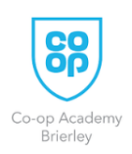
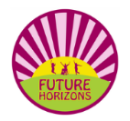
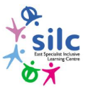



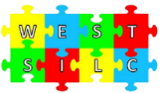
Outcomes
Compass House is a great youth voice project that enables staff and students from across seven settings to work in partnership to create a valuable work experience project.

112 students from across the seven settings had the opportunity to work at the Compass House pop up shop, with hundreds of students contributing to making products to sell.

The project offers valuable learning opportunities for students; these include
- Interacting with peers from other schools and extended friendship groups
- Mathematical skills when dealing with product sales
- Promotional and marketing skills
- Customer service skills
- Fine motor skills whilst making products
- Decision making

Students said:
“I love coming to Compass House.”
“I am enjoying the market and selling things.”

Staff said:
“Today was the first time one of our students has travelled by train.”
“It is our favourite project of the year.”

Social Media Reach
Compass House has a facebook page, students created social media posts that were shared during the month prior to the opening of the shop.

During the 4 weeks prior to the shop opening, the social media posts received:
- A reach of 10,319 views
- 120 content interactions
