


Leeds SEND Youth Council involvement and achievements
1st September 2024 to 31st August 2025

The Leeds SEND Youth Council is group of young people aged 11 to 25 years old with special educational needs and disabilities (SEND) who live in Leeds or attend school in Leeds.

The Leeds SEND Youth Council take part in a range of youth voice activities that enable them to share their experiences and feedback about SEND services in Leeds.

Feedback from consultations with children and young people with SEND can be found here: https://www.leedslocaloffer.org.uk/have-your-say/children-and-young-people/consultation-feedback

Contact VIC@leeds.gov.uk for more information about the Leeds SEND Youth Council.

Regional representation
Representing the voices of young people in Leeds on a regional level.
Two members of the SEND Youth Council joined the Yorkshire and Humber regional SEND Youth Alliance group to represent the voices of young people in Leeds.

The regional group are:
- Developing a video about EHCP’s for young people
- Representing groups on the SEND Change programme

Campaigns

2024/25 campaign: Mental Health services
The Leeds SEND Youth Council have used existing data and consultation feedback to explore ideas for their next campaign / project.

Members have voted, and their next campaign will focus on mental health support for young people with special educational needs and / or disabilities.

The areas the SEND Youth Council will be working with MindMate on are:
- Mental health support guide for specialist provisions
- Accessible and inclusive mental health support information
- Mental health support for 18 to 25 year olds with SEND
- Review of the MindMate ND hub

In October 2024 the SEND Youth Council took part in a consultation to review the MindMate ND Hub. They have shared their feedback with the MindMate ambassador leading on the review.

In January 2025, members gave their feedback on the new Z-Card before it is launched.

The SEND Youth Council met two Mindmate Ambassadors in May 2025. They gave feedback about accessibility of the website including which pages should have audio. They also shared ideas and suggestions for making the website more accessible and these have been feedback to the website creators.

The SEND Youth Council members were also invited to share their own stories on the Nuerodiversity Hub.

Accessibility of Leisure Centres
The Leeds SEND Youth Council are working with Leeds City Council Leisure Centres and the Commissioning Team to review how accessible and inclusive the Leisure Centre provisions in Leeds are.

Members put together a mystery shopping criteria and visited Leisure Centres across Leeds in April 2025. In July they met with the Leisure Centres manager and the Commissioning team to feedback their findings and made recommendations to improve the accessibility and inclusivity of the centres.

Disability Pride
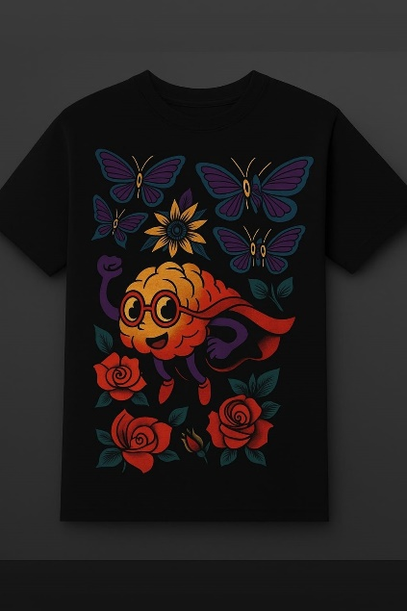
To celebrate Disability Pride in the month of July the group came up with ideas of how they would like to raise awareness of disabilities.

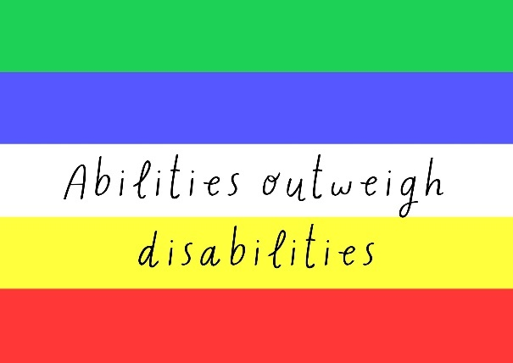
They designed stickers which they handed out to almost 100 people at 2 Breeze events in Leeds with the slogan: Abilities Outweigh Disabilities.

They designed bespoke t-shirts which they wore at Breeze and will wear at SEND Youth Council meetings and other events.

They also created a digital banner which was displayed during July in Kirkgate Market and Millenium Square.

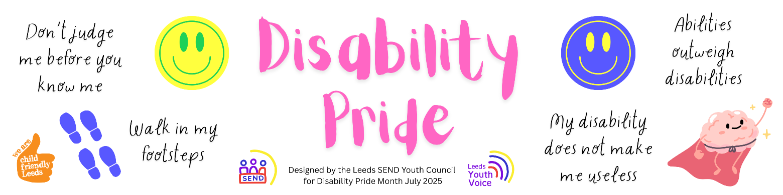

Recruitment and Commissioning panels
Members of the Leeds SEND Youth Council take part in young people recruitment and commissioning panels.
Short Break Tender Evaluation – 8 young people took part in the commissioning panel. They rated each providers response to a question about youth voice, and gave their feedback to the commissioning team.

Sessions
Each month members of the Leeds SEND Youth Council are invited to join sessions, the sessions are an opportunity for members to share their feedback and views with SEND services.
Takeover of the Children and Families Partnership Board: members of the group worked with representatives from youth groups across the city to plan the takeover of the Children and Families Partnership Board in January 2025. Two members attended the takeover on the 30th January to represent the SEND Youth Council.

Developing youth voice resources for educational settings – members took part in a consultation lead by the one SEND team to give their views and feedback about youth voice in educational settings. The team will be developing resources based on the feedback from the group.

Opportunities to play – Members took part in a consultation to share with Leeds City Council what play means to them, where they plan and how play can be improved in Leeds. Guidance will be developed which will be shared with developers of play spaces.

Education Health and Care Assessment form – Members gave their feedback on the new EHC assessment self-request form for young people. All feedback was shared with the team developing the form.

Change Programme: Members of the SEND Youth Alliance came to visit the SEND Youth Council. They took part in some Peer Research for the Change Programme (DfE) sharing their experiences of the Education system, EHCPs and SEND services.

Leeds 0-19 PHINS (Public Health Integrated Nursing Services) – Members took part in consultation about Chat Health, a text service for young people to ask health questions, to make sure that these services are as useful as they can be in the future for other young people.

STARS Team Proposed Changes
The SEND Youth Council were consulted by the SEN support team about proposed changes the STARS service (Specialist Training in Autism and Raising Standards). They are wanting to move to a needs-led model to ensure earlier and more equitable support. The SEND Youth Council were supportive of the changes and gave their feedback and ideas which will influence the decision made by the SEN support team.

Rowland Play Patch
In August 2025 the group visited Rowland Play Patch to consult around a new sensory garden. The group gave their ideas, feedback and recommendations which will be shared with the designer to influence the design and creation of a new sensory garden in the space in Autumn 2025.

Leeds Local Offer Website Review
In August 2025 members reviewed the Leeds Local Offer website and gave their feedback and recommendations about the information and the accessibility of the site. This feedback will be used by the officers who manage the website to make improvements to the site.

Consultation surveys
Consultation surveys are shared with the Leeds SEND Youth Council to enable them to give their views and feedback via online surveys.
The Big Conversation – The Big Conversation is led by the Children’s Commissioner and a chance for children and young people to have their say about the issues that are important to England’s children.

Youth Activity Funding – The Communities Team at Leeds City Council have asked young people with SEND what activities they would like to see in their local community. All responses are shared with the community committees to help with their decision making on funding for activities.

Future of a National Youth Council – The National Youth Agency have asked young people to share their views and thoughts on a National Youth Council.

Digital emotional wellbeing service – The NHS West Yorkshire Integrated Care Board have asked young people to share their views and feedback on a digital emotional wellbeing service.

Experiences of health care - West Yorkshire Voice asked young people to share their experiences of health and using health and care services via an online survey. A reported outlining the findings was presented at the Integrated Care Board (ICB) board meeting on the 24th September to help inform and short future delivery of services.

Transitioning from children’s to adult services in Health – The NHS Youth Forum asked young people to share their experiences of transitioning from children’s to adult services in Health via an online form.

Green Spaces Summer consultation 2025
Leeds City Council’s Parks and Countryside team were asked the public including young people to share their views on what makes a park great and what their favourite park is in Leeds.

