Early Help Consultation Feedback
Thank you for inviting the Early Help team to the SEND summit to help us develop the SEND Coordinator role in Family Hubs.
Activity 1:
We asked you to draw a person and the write what you think the SEND Coordinator should be like. The drawings were amazing, here’s a couple of examples:
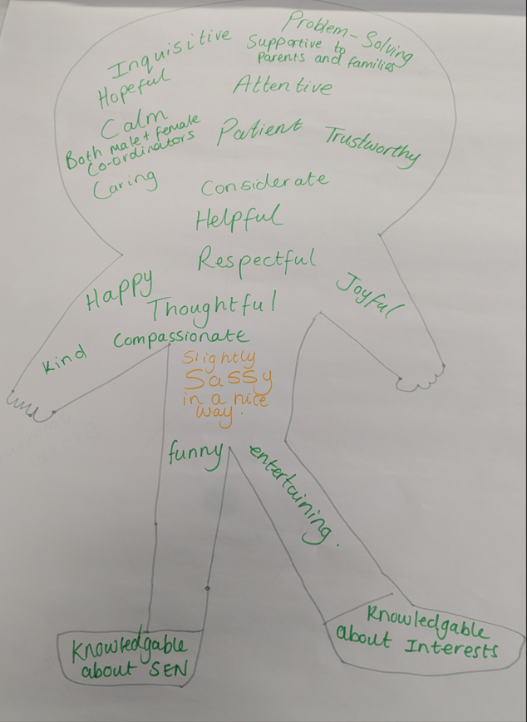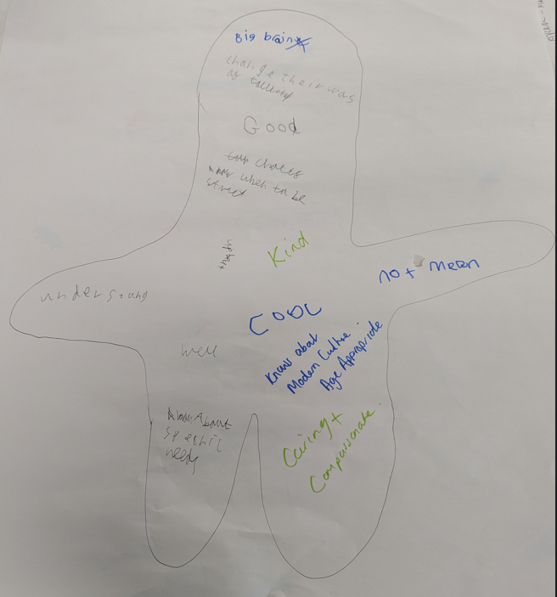
The most popular words you chose were caring, supporting, helpful, good and funny.
What we plan to do: When the SEND Coordinators start work, we will show them your drawings and will also review with families to see if they think the workers are caring, supporting, helpful, good and funny.
Activity 2:
We asked you to rate some of our ideas for the SEND Coordinator role, by putting a green sticker on the ones you liked, a red sticker on the ones you didn’t like, and an orange sticker on the ones you were unsure about. These were the ideas:
- Helping parents and carers get the right support
- Helping you to go to school or colleague
- Helping you to find a job
- Helping schools and colleagues
- Helping everyone who works with children to understand SEND
- Telling you about fun activities that are going on in Leeds
- Telling you what your rights are
- Helping you to meet new friends
- Helping you to say what you think and what you want to happen
- Helping you to be independent
As a group, you liked most of the ideas, the ones you were not sure about were:
- Telling you what your rights are
- Helping you to say what you think and what you want to happen
What we will do: We will speak to the SEND Coordinators about the ideas you liked and put a plan in place to make sure this is how we are helping children, young people and families.
There were also some new ideas from the tables, for example, supporting brothers and sisters and other family members.
We hope we can come to another SEND Summit in the future to tell you about how the SEND Coordinators are supporting families in Leeds.
Thank you, Anna Bedford and Lyndsey Mortimer

