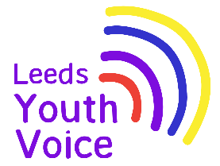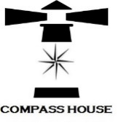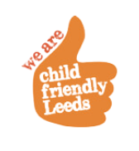

**Compass House Christmas 2024**

**Summary Report**

**Background**

In 2017; 102 students from across specialist learning provisions in Leeds took part in the Mark Your Mark ballot (largest youth consultation in the UK). From the ten issues the students collectively voted that a Curriculum to Prepare us for Life as the top issue for them. Students tookover the SEND Partnership Board (previously Complex Needs Partnership Board)in November 2017 and spoke to the board about what a curriculum for life means to them and how they would like valuable work experience.

The Compass House project was set up in 2018. Staff from specialist schools across Leeds supported students to come together to plan and open their very own pop up shop for one week during the month of December in Kirkgate Market. Students made all decisions about the shop (known as Compass House) including making all the products to sell.

Due to the success of the project in 2018, this has now become an annual event.

**Compass House December 2024**

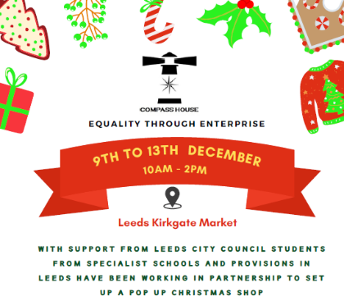Supported by the Voice, Influence and Change Team; students from East SILC, West SILC, Broomfield South SILC, Green Meadows Academy, The Lighthouse School and Future Horizons met monthly, September to December 2024, to plan the opening of the 2024 Compass House pop up shop.

Students made all the decisions about promotion, products to sell and shop décor.

The Compass House pop up shop opened Monday 9th to Friday 13th December 2024, 10am till 2pm in Kirkgate Market.

Leeds Kirkgate Market provided the unit free of charge for the week.

Yorkshire Voice captured the Compass House project as an [article on their website](https://yorkshirevoice.com/leeds-specialist-school-students-sell-christmas-gifts-to-gain-experience).

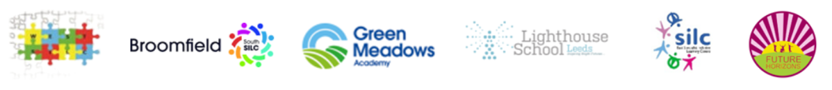

**Outcomes**

Compass House is a great youth voice project that enables staff and students from across six settings to work in partnership to create a valuable work experience project.

91 students from across the six settings had the opportunity to work at the Compass House pop up shop, with hundreds of students contributing to making products to sell.

The project offers valuable learning opportunities for students; these include

* Interacting with peers from other schools and extended friendship groups
* Mathematical skills when dealing with product sales
* Promotional and marketing skills
* Customer service skills
* Fine motor skills whilst making products
* Decision making

Students said:

“It might have been the best day ever”

“Lots of people bought our things, it was great”

**Social Media Reach**

Compass House has a facebook page, during the month prior to opening each day students posted to promote the opening of the shop.

During the 4 weeks prior to the shop opening, the social media posts received:

* A reach of 4,066 on facebook
* Engagement with 314 facebook users

