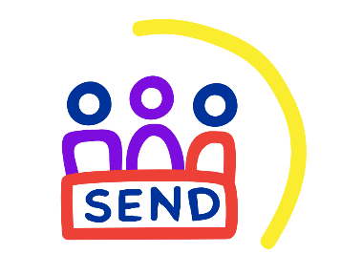

**Voice and influence of children and young people with SEND in Leeds**

**Leeds Area SEND and AP Partnership Board**

The Voice and Influence Transparency Working Group report back to the Leeds Area SEND and AP Partnership Board.

**Six monthly SEND voice and influence report**

The purpose of the report is to collate voice and influence work from across the city, champion good practice and raise awareness of the issues raised.

All groups, specialist provisions, mainstream schools, APs and AIPs are asked to contribute to the six-monthly voice and influence reports to and share the issues raised by the young people they work with.

**Voice and Influence Transparency Working Group**

The voice and influence transparency working group is a subgroup of the Leeds Area and SEND AP Partnership Board. The group look into the issues and challenges raised by children, young people, parents and carers.

**Leeds SEND Youth Council**

The Leeds SEND Youth Council is a group of fifteen young people aged 11 to 25 years old with special educational needs and disabilities (SEND) who live in Leeds or attend school in Leeds.

* Commissioning panels
* Recruitment and selection panels
* Service consultations
* Make your mark
* Review Leeds Local Offer
* SEND and Inclusion Strategy

**Young people in school (specialist, alternative provisions and mainstream)**

The Voice, Influence and Change Teamwork with all settings in Leeds to ensure students have a voice and influence within the city.

* SEND Summit
* Service consultations
* Make your mark

**Takeover of the Leeds Area SEND and AP Partnership Board**

The Voice, Influence and Change Team coordinate young people in Leeds taking over the Leeds Area SEND and AP Partnership Board as part of national takeover challenge.

The takeover is an annual event that takes place in November.

Young people are supported to share with board members the key issues and challenges they face in their day to day lives and celebrate what Leeds is doing well.

For more information about the voice and influence of children and young people with SEND in Leeds visit <https://www.leedslocaloffer.org.uk/have-your-say/children-and-young-people> or email [VIC@leeds.gov.uk](mailto:VIC@leeds.gov.uk)