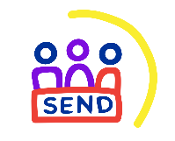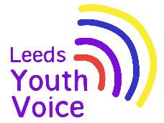

**Leeds SEND Youth Council involvement and achievements**

**1st September 2024 to 31st August 2025**

The Leeds SEND Youth Council is group of young people aged 11 to 25 years old with special educational needs and disabilities (SEND) who live in Leeds or attend school in Leeds.

The Leeds SEND Youth Council take part in a range of youth voice activities that enable them to share their experiences and feedback about SEND services in Leeds.

Feedback from consultations with children and young people with SEND can be found here: <https://www.leedslocaloffer.org.uk/have-your-say/children-and-young-people/consultation-feedback>

Contact [VIC@leeds.gov.uk](mailto:VIC@leeds.gov.uk) for more information about the Leeds SEND Youth Council.

|  |
| --- |
| **Regional representation**  Representing the voices of young people in Leeds on a regional level. |
| Three members of the SEND Youth Council joined the Yorkshire and Humber regional SEND Youth Alliance group to represent the voices of young people in Leeds. |
| **Campaigns** |
| **2024/25 campaign**  The Leeds SEND Youth Council have used existing data and consultation feedback to explore ideas for their next campaign / project.  Members have voted, and their next campaign will focus on mental health support for young people with special educational needs and / or disabilities. |
| **Recruitment and Commissioning panels**  Members of the Leeds SEND Youth Council take part in young people recruitment and commissioning panels. |
| **Short Break Tender Evaluation –** 8 young people took part in the commissioning panel. They rated each providers response to a question about youth voice, and gave their feedback to the commissioning team. |
| **Sessions**  Each month members of the Leeds SEND Youth Council are invited to join sessions, the sessions are an opportunity for members to share their feedback and views with SEND services. |
| **Opportunities to play –** Members took part in a consultation to share with Leeds City Council what play means to them, where they plan and how play can be improved in Leeds. Guidance will be developed which will be shared with developers of play spaces.  **Education Health and Care Assessment form –** Members gave their feedback on the new EHC assessment self-request form for young people. All feedback was shared with the team developing the form. |
| **Consultation surveys**  Consultation surveys are shared with the Leeds SEND Youth Council to enable them to give their views and feedback via online surveys. |
| **Experiences of health care**  - West Yorkshire Voice asked young people to share their experiences of health and using health and care services via an online survey. A reported outlining the findings was presented at the Integrated Care Board (ICB) board meeting on the 24th September to help inform and short future delivery of services.  **Transitioning from children’s to adult services in Health –** The NHS Youth Forum asked young people to share their experiences of transitioning from children’s to adult services in Health via an online form. |