

## Learning Inclusion

**Guidelines for Specific Literacy Difficulties: Dyslexia**

These guidelines have been developed by members of the Learning Inclusion

**Contents**

1. Introduction
2. What is Dyslexia?
3. The Role of Schools
4. Assessment and support for schools
5. Frequently Asked Questions
6. References

**Appendices**

Appendix 1: Expectations for individual requests for intervention and support from SENIT (School Age)

Appendix 2: Learning Inclusion Training Offer for Dyslexia and literacy difficulties

Appendix 3: Family Guide to Dyslexia

Appendix 4: A Band SpLD Funding for Inclusion

Appendix 5: A Model Policy for Schools

Appendix 6: Access Arrangements

Appendix 7: Useful contacts

1. **Introduction**

Welcome to our revised Learning Inclusion guidelines on the Specific Learning Difficulty, Dyslexia. These guidelines have been written to support schools and settings to develop their understanding of and provision for children and young people (CYP) in Leeds with a profile of Dyslexia. We hope they provide a useful resource for schools and settings to develop their practice working with CYP with or without a formal diagnosis of Dyslexia.

**2. What is Dyslexia?**

The word *Dyslexia* originates from ancient Greek and can be literally interpreted as 'a difficulty with words.' It has a high prevalence rate and is thought to affect around 10% of the population.

In June 2009, Sir Jim Rose published a report on Dyslexia. The report included advice to British schools identifying and teaching children and young people with Dyslexia. Rose's definition, seen here below, has been endorsed by leading researchers, practitioners and charities throughout the UK.

**The Rose Definition**

* *'Dyslexia is* a *learning difficulty that primarily affects the skills involved in accurate and fluent word reading and spelling.*
* *Characteristic features of dyslexia* are *difficulties in phonological awareness, verbal memory and verbal processing speed.*
* *Dyslexia* occurs across *the range of intellectual abilities.*
* *It is best thought of* as a *continuum, not* a *distinct category, and there* are *no clear cut-off points.*
* *Co-occurring difficulties may be seen in aspects of language, motor co-ordination, mental calculation, concentration and personal organization, but these* are *not, by themselves, markers of dyslexia.*
* *A good indication of the severity and persistence of dyslexic difficulties can be gained by examining how the individual responds* or *has responded to well-founded intervention.' (Rose J, 2009)*

The Learning Inclusion Service in Leeds has adopted the Rose definition as a basis for identification of dyslexia. We recognize that some individuals also experience difficulties with visual[1] and auditory processing which exacerbate learning (BDA 2010).

The last bullet point is particularly important as it recognises that most individuals respond to well-founded intervention. This helps to stress the importance of schools providing appropriate provision to ensure that all CYP with a profile of dyslexia make progress and achieve their potential.

**3. The Role of Schools**

The SEND Code of Practice (2015) requires schools to adopt a Graduated Approach in supporting CYP with SEND (including dyslexia). The Graduated approach involves a cyclical four-part process (*Assess, Plan, Do, Review).* Through this cycle, actions are reviewed and refined as understanding of a CYP’s needs and the support required to help them secure good outcomes increases.

The Rose definition explains how Dyslexia exists across a continuum, with some learners experiencing mild difficulties whilst a few may be severely affected. It is important, therefore, to consider the type of provision and support appropriate to each individual with dyslexia, based on their profile of need.

The Learning Inclusion Service has created a Provision Grid (seen here) which is available on Leeds for Learning. This is designed to support our schools to plan provision across a continuum of need for CYP with a profile of dyslexia with or without a formal identification.

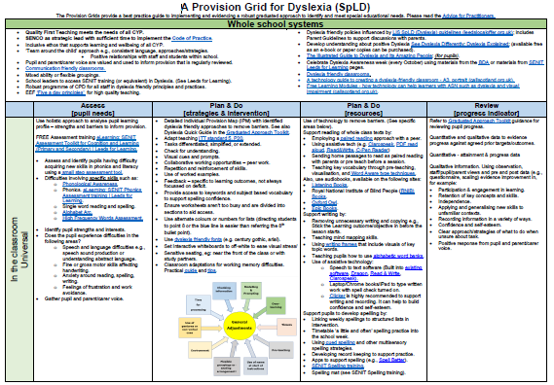

#### 3.1 UNIVERSAL PROVISION

The SEN Code of practice (2014) encourages schools to take a proactive approach to supporting CYP across their provision. This involves adopting universal school policy to highlight dyslexia friendly practice and creating a positive and inclusive learning environment. The table below is taken from our provision grid. It contains links to a variety of resources to support schools to develop their practice in this area.

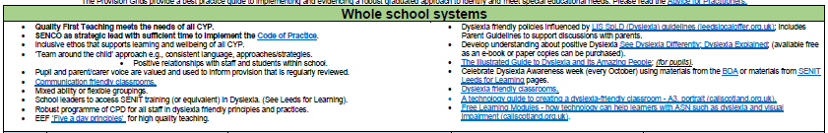

(Extract from Provision Grid for SpLD)

High Quality Teaching is a phrase used to describe the universal offer for all children and young people within a school or setting; the effective inclusion of all individuals in high-quality everyday teaching. Here, the teacher is expected to make reasonable adjustments to classroom practice to enable CYP to learn inclusively and meaningfully alongside their peers. We encourage schools to consider what adjustments could be used to improve curriculum access to CYP with dyslexia by using the provision grid as a starting point.

#### 

(Extract from Provision Grid for SpLD)

#### Through our Graduated Approach Toolkit, we encourage schools to use comprehensive and efficient range of documentation, to ensure that there is good awareness of the CYP’s needs, including the provision in place. A key document is the Individual Provision Map shown below.

#### 

#### In the IPM, the focus on high quality teaching at the universal level is key. This might include:

* + Teaching strategies that work well for the pupil.
  + Reasonable adjustments.
  + Adaptations and resources.
  + Assistive technology.
  + Strategies that the pupil will employ.

#### A range of Quick Guides are available to support the Graduated Approach Toolkit. These include: Attention and Concentration, Speed of Processing, Phonological Awareness, Working Memory and SpLD Dyslexia. The SpLD Dyslexia Quick Guide is shown below as an example.

#### 

#### 3.2 TARGETED & PERSONALISED PROVISION

The [Education Endowment Foundation](https://educationendowmentfoundation.org.uk/tools/guidance-reports/?gclid=EAIaIQobChMIkdGjrcnd8gIV0KfVCh2D8AtxEAAYASAAEgKYkfD_BwE) is an independent charity that aims to support schools by examining research and examining evidence-based resources designed to improve practice and boost learning. They suggest several features of what makes an effective intervention. They suggest that provision should be:

(EEF)

Most programmes designed for learners with dyslexia follow a structured multi-sensory phonic-based programme and focus on developing the mechanics of literacy. This includes:

In the Graduated Approach Toolkit, you will find a wide range of Intervention Guides and Records, including Active Literacy Kit, Alpha to Omega, and many more. They provide a brief overview of the intervention and allow for recording baseline assessments, expected impact, actual impact, and a review. A template example is shown below.

#### 

#### 3.3 TARGETED

Targeted support for learners with a profile of dyslexia can help to improve skills in reading, spelling or written expression. These are often time limited group interventions, designed to increase rates of progress and put them back on course to meet or exceed age related expectations. Progress of individuals who receive targeted support should be regularly monitored in school.

Our [Provision](https://www.leedsforlearning.co.uk/Page/17338) Grid includes programmes that are routinely recommended by our service. All are proven to be effective and target the specific areas of difficulty dyslexic pupils may encounter.

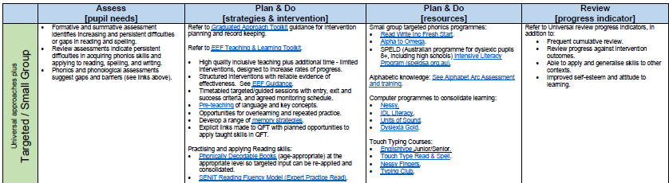

(Extract from Provision Grid for SpLD)

#### 3.4 PERSONALISED SUPPORT

Personalised provisiondescribes a more tailored offer of support forlearners with significant or persistent difficulties. This is the next stage of the school’s graduated approach in supporting pupils.

***At this level provision should include:***

* Ensuring the pupil is on the school's SEN register.
* Recording CYP under the term ‘SpLD’ (Specific Learning Difficulty) on the annual census.
* Summative assessment to outline the individual’s learning profile and identify appropriate provision.
* Diagnostic assessment to outline gaps in learning and identify an individual’s starting point in intervention
* Individual Provision Map[2] outlining:
* Reasonable adjustments within Quality First teaching to remove barriers to learning
* Targeted/Personalised intervention (as outlined below)
* Timetable to monitor provision (including a record of pre-post measures)

Personalised provision may also include:

* Additional advice from specialists (when difficulties persist)

Programmes may be the same as those offered at targeted level but delivered individually with the emphasis on adapting the pace of the programme to meet individual needs.

Further examples of Personalised Intervention are shown here:

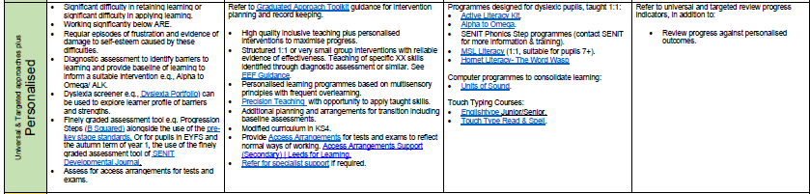

(Extract from Provision Grid for SpLD)

The programmes listed on our continuum are by no means exhaustive. Schools can use alternative, comparable programmes, provided they can evidence that the individual has made accelerated progress in the targeted area of learning. For further details of reading and spelling interventions visit the new [Brooks’s What Works for Literacy Difficulties?’ 2020](https://www.theschoolpsychologyservice.com/wp-content/uploads/2020/11/What-Works-for-Literacy-Difficulties-6th-Edition-2020.pdf)

**3.5 SPECIALIST SUPPORT**

A small minority of learners with Dyslexia will experience significant difficulties learning to read and spell. Such difficulties are likely to be pervasive and persist despite high levels of provision (as outlined above). Such learners may require more specialist support to ensure that they make progress and reach their learning potential. Our funding for inclusion (FFI) model outlines the type of support schools would be expected to provide. This is updated on an annual basis. SENCos are advised to refer to the latest guidance.

The table on the next page outlines the criteria and provision for such pupils.

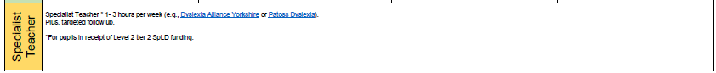

(Extract from Provision Grid for SpLD)

**3.6 The Role of Governors in Schools**

Governing bodies of maintained school and proprietors of academy schools are required to monitor the effectiveness of provision and outcomes for individuals with SEND and publish an annual SEN Information Report as outlined in the SEND Code of practice 2015.

#### The Continuum of Need for CYP (Dyslexia) in Leeds

|  |  |  |  |  |
| --- | --- | --- | --- | --- |
| Mild  Severe | **Funding Stream** | **Continuum** | **Outline of Provision** | **Type of Provision** |
| Notional SEN Budget  *Schools are advised to use the notional SEN budget to pay for up to £6000 worth of special educational provision to meet a child’s SEN* | **Universal** | **Whole School** Planning to embed Dyslexia friendly principles  **Classroom** Reasonable Adjustments made within quality first teaching to support individuals to access the curriculum access | Whole School Awareness Weeks/ Dyslexia friendly books  SPLD Personalised Support plan in place for all classes |
| Universal Support *plus* **Targeted Support** | Small Group Support up to 6 individuals (3 x weekly 20-30 minutes by trained teaching assistant or teacher) | SPLD Personalised Support plan in place for all lessons plus SpLD literacy intervention |
| Universal Support *plus* **Personalised support** | 1:1 Support 3 x weekly 30 minutes by trained teaching assistant or teacher in reading and/or spelling | SPLD Personalised Support plan in place for all lessons plus SpLD literacy intervention |
| A Band SpLD FFI Level 2 tier 1  Standard Scores below 75 in reading and spelling | Universal support *plus* **daily Personalised support** | 1:1 Support daily by trained teaching assistant or teacher in reading *and* spelling | SPLD Personalised Support plan in place for all lessons plus daily SpLD literacy interventionfor reading, spelling and dictation.  Support for study skills |
| A Band SpLD FFI Level 2 tier 2  Standard Scores below 70 in reading and spelling | Universal support *plus* **daily specialist support** FFI (Level 2) | 1:1 support plan delivered by Specialist Teacher (Level 7 qualification in SpLD) for 1 hour per week plus follow up planning to be carried out by trained teaching assistant or teacher daily for 30 minutes in reading, spelling and dictation. | SPLD Personalised Support plan in place for all lessons plus daily SpLD literacy interventionfor reading, spelling and dictation.  Support for study skills (High School) |

See also Appendix 4: FFI for SpLD Dyslexia

**4. The Role of the Local Authority**

**4.1 Support and Training for Schools**

The Learning Inclusion Service is committed to providing high quality training and advice to schools and settings aimed at developing inclusive practice and adopting a graduated approach to supporting individuals on the dyslexic continuum.

Our training covers a range of aspects including:

* Primary and Secondary capacity building courses for school leaders and SENCos
* Dyslexia Awareness, Whole School Ethos & Reasonable Adjustments in class
* Use of formative and diagnostic assessment to identify next steps for CYP.
* Targeted and Personalised Intervention to raise achievement for individuals on the dyslexic continuum
* Information for parents & carers of children with difficulties on the dyslexic continuum

Refer to appendix 2 for details of our current offer.

**4.2 Assessment and Consultation**

The vast majority of CYP with a profile of dyslexia can make progress and achieve their potential through high quality provision within school without the need for formal assessment from a specialist.

However, a small minority of learners may demonstrate significant difficulties, such that more specialist advice and support is required. In such cases schools can request specialist support from the Learning Inclusion Service. Support can be accessed from two teams within the service:

* **Specialist teachers and assessors within the SENIT Team.** The criteria for individual consultation can be found in Appendix 1.
* **Educational Psychology Team.** Concerns can be discussed with the school linked Educational Psychologist through school planning meetings or City-Wide Consultation and Support sessions.

Both teams will carry out a consultation with the school in the first instance, in order to agree next steps. The purpose of the consultation will be to discuss the level of provision currently in place for the pupil and consider the impact upon the pupil. This may not always result in a direct assessment.

Where recommendations have been fully implemented in line with our criteria (See appendix 1), the service may agree to an assessment from a specialist assessor.

Such assessments may include standardised assessments to investigate:

The assessor will also gather information about an individual's history of learning, past support, and intervention, including information from the parent and the pupil. This may include:

**Information from Parents/ Carers**

The Learning Inclusion Service would always aim to consult with parents or carers to gather information about their child and contribute to the assessment process. This may include familial risk factors (e.g., do parents/siblings have similar difficulties or identified dyslexia?), information around recent medical checks such as speech, hearing and vision. Further information for parents is provided in Appendix 3 (Family Guide to Dyslexia).

**Will all individuals receive an identification of Dyslexia?**

Identification will be made if, following a sustained period of closely targeted and monitored provision, the impact on the pupil is ‘persistent and severe.’ This links with the last bullet point of Rose's definition which stresses the importance of providing individuals with *‘well-founded intervention.'* Where appropriate, reports will be peer moderated by colleagues who hold a professional qualification in assessing dyslexia.

Some individuals may have significant co-occurring difficulties that suggest that such a label may not be an accurate way of describing their difficulties. In such instances, this will be discussed in the assessor's report, with the school and parents.

#### 4.3 Resourced Provision

Our resourced provision for learners with severe dyslexia is located at Roundhay School and caters for pupils in Years 7 to 13. The Dyslexia Base is staffed by specialist teachers and in-class support is provided by Teaching Assistants who are trained in the strategies necessary for working with dyslexic pupils. The Dyslexia Base is open to pupils attending schools within the Leeds Education Authority. All pupils taught in the Base will have an EHC plan specifying specific learning difficulties (dyslexia).

Contact details for this provision are included in appendix 6.

**5. Frequently asked questions**

***Are all children with reading difficulties dyslexic?***

There are two distinct forms of reading disorders in children: dyslexia (a difficulty in learning to translate print into speech) and reading comprehension impairment. Some children with reading difficulties may be able to read accurately but struggle to understand what they have read. These children would not be described as having dyslexia. In such cases, provision should focus on developing oral and written comprehension skills.

***Why do some children experience dyslexia?***

Research into causation is still ongoing. The causes of dyslexia are complex and these may vary between individuals but are likely to include difficulties with phonological processing (including phonological awareness, phonological memory and phonological processing speed). Sensory processing issues and difficulties in becoming automatic with key literacy skills may also play apart.

***Is dyslexia hereditary?***

Yes. Understanding the interaction between genes and the environment can be complex. However, long held theories that SpLD (dyslexia) can be inherited have been substantiated. This is why it is important to check whether family members have experienced similar difficulties.

***Can dyslexia occur across the full range of abilities?***

Yes, whilst it can be useful to explore a pupil’s cognitive ability to inform provision, assessors recognize that dyslexia can occur in individuals of all levels of ability. It is therefore no longer acceptable to use a discrepancy model to decide who is and who isn’t dyslexic; however an uneven profile of strengths and weaknesses would be expected, such that scores in reading and spelling would be ‘unexpected’ in related to other skills.

***Who identifies dyslexia?***

A formal identification would be made by a specialist teacher with an accredited Level 7 Diploma in Specific Literacy Difficulties or an Educational Psychologist. However, we encourage all schools to attend training so that they can appropriate identify which CYP have a profile of dyslexia so that the right provision can be in place without the need for a formal identification.

With appropriate training, staff working in schools are well placed to identify which CYP in their setting have a dyslexic profile without requiring formal assessment. However, in some cases, a formal assessment may be beneficial in order to advise which provision is appropriate, particularly when the CYP is experiencing difficulties such that he/she shows limited response to intervention.

***My daughter received a diagnosis of SpLD (dyslexia) whilst at unive rsity. Why was this not recognised earlier?***

Dyslexia exists on a continuum. Not all individuals are severely affected and it is possible for individuals to succeed, with some compensatory strategies, throughout their school life and examinations without causing concerns around progress. As curriculum or subject demands become more challenging and complex, underlying difficulties may become evident. It may only be at this point that it is appropriate to investigate such difficulties further.

***If******a child is recognised as dyslexic, should a statutory assessment be carried out?***

*The vast majority of children and adults with dyslexia will not require additional extra funding or an Education Health and Care* Assessment *from the local authority.*

Children with dyslexia should receive a graduated response to their identified needs as outlined in the SEN Code of Practice (2015). The needs of most can be met through High Quality Teaching at the Universal level and interventions at Targeted and Personalised levels, alongside careful monitoring and evaluation of this provision (see Appendix 1).

Schools are expected to meet the first £6000 of the cost of special educational needs provision for a pupil. However, school may be able to obtain 'top-up' funding through Funding for Inclusion (FFI) if the pupil meets the criteria. To qualify, individuals will have accessed specialist programmes, differentiated High Quality Teaching and appropriate ICT (as part of a costed provision map) and this must be in place for at least two terms. Individuals will also need an assessment by an SEN Officer or Educational Psychologist, who will also consider the length and quality of the intervention.

***Why are SENST assessments part of the graduated approach and not ‘standalone?***

SEN Specialist Teachers (SENST) are a small group of specialist teachers who work within SENIT Team across Leeds. Our role is to support schools with a range of SEND needs of which CYP with dyslexia are included.

We recognise dyslexia as a high incidence learning difference; thought to affect around 1 in 10 of the population. The Rose definition explains that ‘well founded intervention’ (including adjustments within the classroom) can have a significant impact upon progress and self-esteem of CYP. Our Capacity Building Courses (outlined in appendix 2) are part of our commitment to schools to develop their capacity to support CYP with a profile of dyslexia across a continuum of need. Provision is not dependent upon a formal identification of dyslexia.

However, we also recognise that for some learners, dyslexia can have a significant impact on their ability to make progress, despite high levels of provision. For this cohort, provision may require high levels of personalised or specialist teaching that may be outlined as part of the school’s Graduated Approach. This forms an important part of our assessment process and allows us to evaluate how well a CYP has responded. This in turns supports schools to correctly identify the level of provision the CYP may need.

**7. References**

***Special Educational Needs and Disability Code of Practice:* 0 *to 25 years*** DfE/DfH (2015)

***Identifying and Teaching Children and Young People with Dyslexia and Literacy Difficulties*** Rose J. (2009) London: DFCS

***The Dyslexia Debate*** Elena Grigorenko and Julian Elliott, (2014), Cambridge University Press

**Appendix 1: Specific Learning Difficulties: Expectations for individual CYP requests to SENIT (school age)**

It is our ambition that all schools and settings across Leeds are able to meet the needs of all children and young people with dyslexia with provision reflecting the continuum of need. The CYP does not need a formal identification of dyslexia or dyscalculia for a setting to access support. Our level 1 and 2 SpLD Capacity Building courses have been designed to support schools through this process.

For pupils presenting with more severe and persistent dyslexic type needs:

* School has attended SENIT Level 1 Dyslexia Capacity Building training or an equivalent.
* Standardised scores 80 or below in reading and spelling.
* Evidence of 2 cycles of the graduated approach as described above. Refer to the SpLD (Dyslexia) Provision Grid.
* Impact data indicates that despite appropriate intervention over 20 weeks pupils appear more resistant to intervention compared to their peers.

***P***

**Appendix 2: Learning Inclusion Training Offer**

|  |  |  |  |  |
| --- | --- | --- | --- | --- |
| **Course** | **Focus** | **Additional Information** | **Training Length** | **Contact Details** |
| **Dyslexia Capacity Building Course Level 1 Primary** | Dyslexia awareness, Assessment, Identification, support and whole school capacity building | Delegates will receive a workbook, toolkit and appendices to support further CPD in dyslexia. | 2 days for SENCos & Literacy Lead  plus eLearning CPD for whole school (twilight training) | Visit [www.leedsforlearning.co.uk](http://www.leedsforlearning.co.uk) for details and dates of courses |
| **Dyslexia Capacity Building Course Level 1 Secondary** | Dyslexia awareness, Assessment, Identification, support and whole school capacity building | Delegates will receive a range of resources to support further CPD in dyslexia (Dyslexipedia). | 2 days for SENCos & Literacy Lead  plus eLearning CPD for whole school (twilight training) |
| **Building**  **Capacity for SENCos Level 2** | Embedding policy and  provision for SpLD (Dyslexia) | Delegates receive a workbook, to support further CPD in dyslexia. | 2 days, 1 school based visit plus reconnector |

|  |  |  |  |  |
| --- | --- | --- | --- | --- |
| **eLearning training for schools**  Book on Leeds for Learning. Also check for new courses available. | | | | |
| **Intervention Type** | **Intervention** | **Focus** | **Suitability** | **Intervention size/Frequency** |
| **Structured**  **Sequential**  **Phonic**  **programmes**  **Reading,**  **Spelling & Dictation** | **Active Literacy Kit** | Alphabet/Sequencing/Phonological Awareness/ Reading & Spelling | Year 2 upwards | 1:1  At least 3 x weekly |
| **SENIT Phonic Programmes**  **(coming soon)** | Phonology/Alphabet/Sequencing/  Dictionary/ Memory/ Reading/ Spelling & Dictation | Reception upwards | 1:1 or small group  At least 3 x weekly |
| **Alpha to Omega** | Alphabet/Sequencing/Dictionary / Memory/ Reading/ Spelling & Dictation | Year 2 to adult | 1:1 or small group  At least 3 x weekly |

|  |  |  |  |
| --- | --- | --- | --- |
| **Targeted interventions (IT Based)** | | | |
| **Intervention** | **Focus** | **Suitability** | **Frequency/Group Size** |
| **Units of Sound**  <https://www.unitsofsound.com/> | Phonics, Reading, Spelling, Memory &  Dictation | Age 8 to adult | At least 3 x weekly. Can be accessed at home.  As per user licenses |
| **Nessy**  [**https://www.nessy.com/uk/product/nessy-reading-spelling/**](https://www.nessy.com/uk/product/nessy-reading-spelling/) | Phonics Reading, Spelling, Memory &  Dictation | Ideal for Primary setting (year 1 to 6) & Key stage 3 |
| **IDL**  [**https://idlsgroup.com/**](https://idlsgroup.com/) | Phonics, Reading, Spelling, Memory &  Dictation | Age 8 to adult |
| **Dyslexia Gold**  [Dyslexia Gold - Reading Unlocked](http://dyslexiagold.co.uk/) | Phonics, visual stress Reading, Spelling, Memory &  Dictation | Early Intervention 4-7  Catch up 7-16 |

**Appendix 3: Family Guide to Dyslexia**

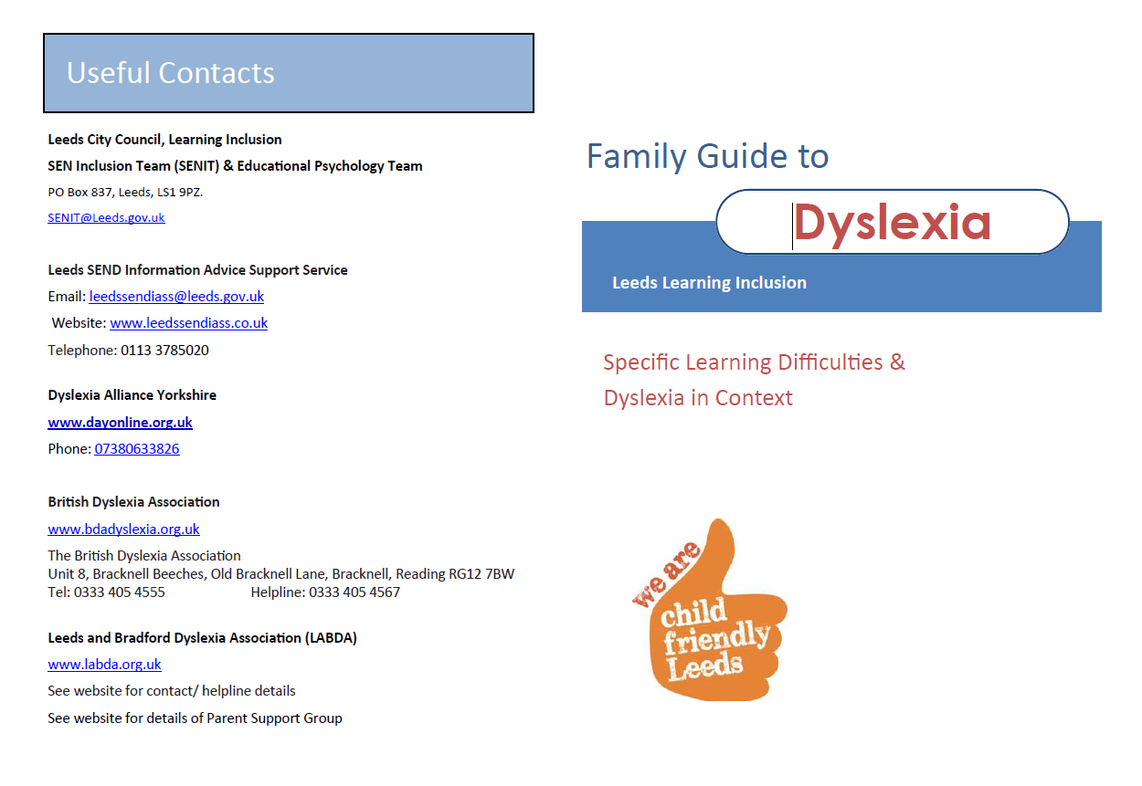

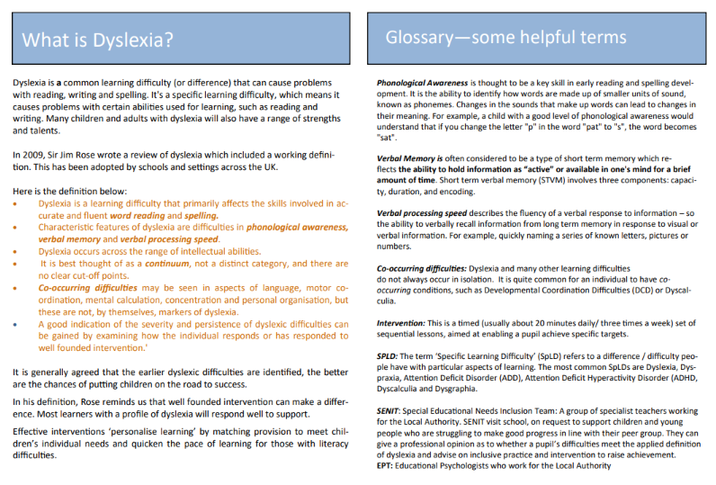

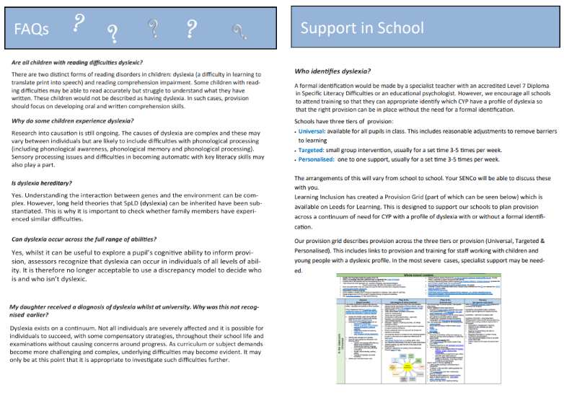

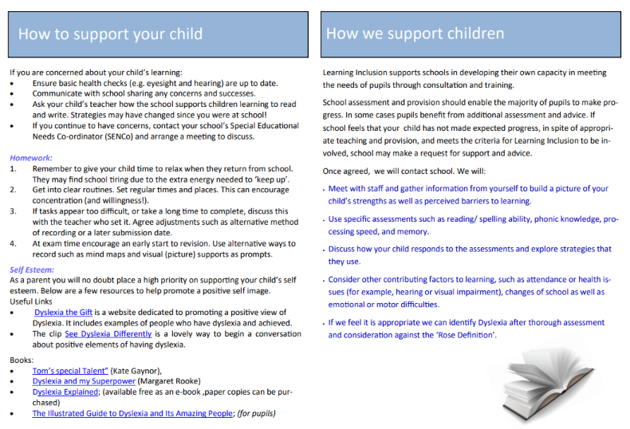

**Appendix 4: FFI for SpLD Dyslexia**

CYP who require additional funding to support their interventions and classroom support will be known to the SENIT team, who will liaise directly with the FFI team to ensure FFI funds are awarded. Settings do not need to apply directly to the Local Authority for the allocation of such funds.

There is overwhelming evidence to suggest that the effects of dyslexia can be mediated by good intervention and support. For a small minority of CYP the effects of dyslexia may be severe and persist, despite well-founded intervention. Where dyslexia is shown to have a disabling effect, the Local Authority may consider it appropriate to provide additional top-up funding through FFI.

It is expected that the following provision should be in place for those CYP on the dyslexic continuum:

* Significant interventions using programmes specifically designed for SpLD
* Individualised specialist teaching for targeted support for three hours per week
* Reasonable adjustments to remove barriers and provide access to High Quality Teaching
* Access to alternative ways of recording including assistive technologies
* Special arrangements for tests and examinations
* Mainstream provision informed by ongoing assessment by specialist teacher and disseminated to mainstream staff
* Modified curriculum to enable specialist input to take place
* Access to suitably trained and experienced support staff

CYP in resource provision will also require:

* access on a daily basis to a teacher/ member of staff who is qualified, trained and experienced in the teaching of CYP with specific learning difficulties.

CYP receive SpLD Level 2 funding if the following criteria are met:

* has a report that clearly states they have a diagnosis of dyslexia (written by qualified professional).
* Have accessed targeted/ personalised support for over 20 weeks and have demonstrated resistance to intervention e.g assessment of word level spelling and reading standardised score remains
  + Below 75 (Level 2 Tier 1)
  + Below 70 (Level 2 Tier 2)
* There is clear evidence of a planned response to recommendations made within the report (evidence of graduated approach/ assess, plan, do, review)
* Provision map clearly reflects provision in place (refer to example individual provision map]
* Settings have attended SENIT Level 1 Dyslexia Capacity Building training or equivalent

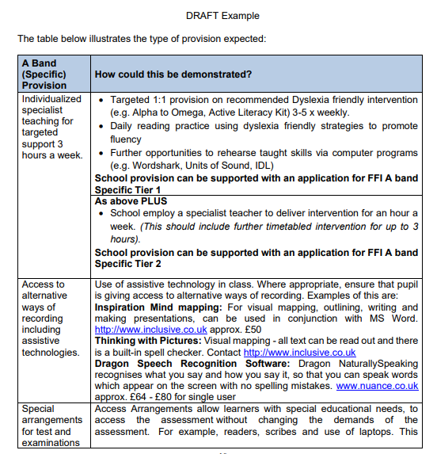

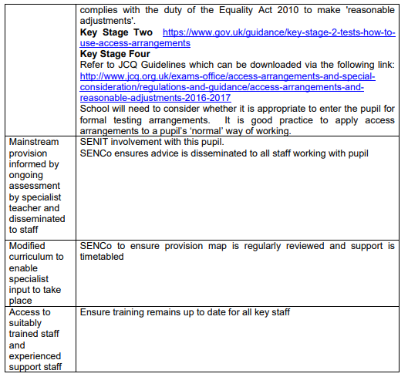



**Appendix 5: A Model Policy for Schools (This will require modification to reflect school practice)**

**Model Dyslexia Policy for Schools**

This policy is to supplement the SEN policy and considers children with a specific difficulty in literacy (dyslexia).

(Insert School Name) is committed to ensuring that all children, irrespective of disability or learning difficulty, are able to access appropriate inclusive and differentiated teaching approaches. The aim is always to raise achievement.

This policy reflects our duty under the Code of Practice for Special Educational Needs (2015) and under the Equality Act (2010)

Reading and writing has a key role in accessing information and demonstrating knowledge throughout school life. As a school we recognise that any difficulty in developing such skills can seriously affect an individual’s learning, confidence, self-esteem and engagement with school.

**Definition**

'Dyslexia' is derived from the Greek and means literally ' difficulty with words or language'. There is no one agreed definition of dyslexia and, despite considerable research, the findings regarding the numbers of individuals and causes of dyslexia vary widely. However, more recent definitions reflect a degree of consensus between academics and professionals and help to clarify a basis for identification.

In June 2009, Sir Jim Rose published his report on dyslexia to the Secretary of State for Education. The report set out guidelines to support schools in identifying and teaching children and young people with dyslexia and literacy difficulties.

Rose summarised dyslexia as follows:

* + Dyslexia is a learning difficulty that primarily affects the skills involved in accurate and fluent word reading and spelling.
  + Characteristic features of dyslexia are difficulties in phonological awareness, verbal memory and verbal processing speed.
  + Dyslexia occurs across the range of intellectual abilities.
* It is best thought of as a continuum, not a distinct category, and there are no clear cut-off points.
* Co-occurring difficulties may be seen in aspects of language, motor co-ordination, mental calculation, concentration and personal organisation, but these are not, by themselves, markers of dyslexia.
* A good indication of the severity and persistence of dyslexic difficulties can be gained by examining how the individual responds or has responded to well-founded intervention.'

Not all children with literacy difficulties will be identified as dyslexic. The term 'dyslexia' is applied, following an assessment by a suitably qualified professional. In this policy we use a broader term SpLD (Specific Learning Difficulty) to encompass a spectrum of needs which may or may not be later identified as dyslexia.

**How do we support children with specific difficulties?**

**The role of the class teacher:**

* To provide an environment which incorporates techniques and strategies recommended for the teaching of individuals with SpLD.
* To choose appropriate learning objectives which challenge and support all individuals
* To manage access strategies and vary teaching styles to support the unique learning profile of each child
* To work with parents to keep them informed of the strategies and approaches being used
* To liaise with colleagues, e.g. SENCos and external professionals to ensure that practice and provision is appropriate

**The role of the Special Educational Needs Co-ordinator (SENCo)**

* To co-ordinate provision for children with Special Educational Needs including those with SpLD (dyslexia)
* To advise on curriculum access to High Quality Teaching and remove barriers to learning
* To monitor and evaluate progress of children with SpLD, ensuring appropriate interventions are in place if required
* To work in partnership with parents
* To remain up to date in current approaches to support children with SpLD and contribute to staff training
* To identify children who may meet the criteria for additional funding

**The role of the Head Teacher**

* To promote a positive ethos of inclusion within the school and community.
* To keep the Governing Body fully informed and work closely with the school's SENCo and their team.
* To oversee adequate provision of resources for children with SpLD based on need and curriculum access.
* To monitor effective teaching and learning for children with SEN, including SpLD, with the Senior Leadership Team.
* To ensure teaching and non-teaching staff have access to good quality training to support their understanding of Specific Learning Difficulties.

**The Role of the Local Authority**

Local Authority Advisors have a key role to play in supporting schools in their provision for children and young people with SpLD. This includes staff training, advice around appropriate provision and developing capacity within schools.

If a child meets the criteria for involvement from our advisory service, school may request an individual consultation. When a child has a more complex profile of needs, he/she may be seen by a member of the SENIT Team or by an Educational Psychologist.

**Private Assessment**

Parents may choose to have a private Educational Psychologist assessment that may result in an identification of dyslexia along with recommendations for intervention. These recommendations can be discussed in school. Many of these recommendations may already be in place in our classrooms through inclusive differentiated classroom teaching and evidence-based interventions and we would strive to meet the needs of all learners. The school cannot always follow specific recommendations. Missing school for external provision can be discussed with the class teacher, SENCo and Head to ensure minimum disruption.

**Funding**

Identification of dyslexia does not attract additional funding through the local authority or through the school. School may be able to obtain top-up funding through Funding for Inclusion if he/she meets the criteria.

**Appendix 6: Access Arrangements**

**Access Arrangements for General and Vocational Qualifications.**

The Joint Council for Qualifications (JCQ) lists many different types of Access Arrangements - ranging from Alternative Accommodation through to Word Processor (use).

It is worth noting that: *'Access Arrangements are not there to give candidates an unfair advantage but to give all candidates a level playing field in which to demonstrate their skills, knowledge and understanding ... The intention behind many access arrangements is to meet the particular needs* of *an individual disabled candidate without affecting the integrity* of *the assessment.''*

Eligibility and/or evidence requirements are listed for each of the Access Arrangements in the "Adjustments for Candidates with Disabilities and Learning Difficulties: Access Arrangements and Reasonable Adjustments" (JCQ) handbook for the current academic year. The duty to make reasonable adjustments is underpinned by the Equality Act 2010.

A diagnosis of dyslexia does not guarantee that the pupil will be automatically given Access Arrangements.

Assessment for Access Arrangements can be carried out by a suitably qualified Assessor, such as the school SENCo, or an Educational Psychologist or Specialist Teacher named by the Head of Centre. Access Arrangements must reflect the pupil's normal way of working. The Handbook gives further guidance on who can carry out assessments.

All applications for Access Arrangements are made online. Assessors should fill in 'Form 8' and leave the testing evidence in the school.

Arrangements which **might** apply to students with Dyslexia:

* Extra time (Usually 25%)
* Reader/ Computer Reader/ *
* Scribe/ Speech Recognition Technology
* Word Processor/iPad

*formal assessment is no longer required. Schools should provide evidence that this is the candidate’s normal way of working.

**Extra Time** (up to 25%)

The candidate will need one of the following documents:



1. An Education Health and Care Plan Assessment relating to **secondary education.**
2. Form 8 detailing an assessment carried out from Year 9 onwards by an Assessor confirming a learning difficulty relating to secondary/ further education. Extra time is awarded to students with standardised scores below 85 in speed of processing, speed of handwriting or speed of reading/reading comprehension etc.

Clarification as to the application of extra time and the criteria that must be met are given in the JCQ handbook, together with a number of examples.

#### Reader / Computer reader

The student may require the whole paper, or just some words, to be read.

A human reader is not allowed in English Language exam in questions that are testing reading, but a computer reader may be used for this.

#### Scribe / Speech Recognition Technology

Scribes should only be requested for candidates who cannot produce written communication by any other means (e.g. word processor).

An assessment of **accuracy, legibility** and **speed** of writing is required. In order to meet the requirements the candidate's spelling accuracy score should be below average; free writing cannot be read by others, or is grammatically incomprehensible; or is produced so slowly that the answers could not be fully recorded even with extra time allowed.

Other Arrangements may be applicable if this is the candidate's **normal way of working.** There is not a requirement to process an application using Access arrangements online for the following arrangements:

* Use of word processor/ iPad
* Use of coloured overlays
* Read aloud (to self)
* Reading Pen
* Prompter
* Supervised Rest Breaks



For Examination on coloured paper, permission must be applied for Early Opening of Papers. When an application for a Computer Reader is approved, centres are permitted to open question papers an hour earlier in order to scan the question paper into an accessible electronic format.

#### Please note that the above is an interpretation of JCQ material. For more detailed information, it is essential to refer to the current JCQ Handbook.

Reference:

'Adjustments for candidates with disabilities and learning difficulties: Access Arrangements and Reasonable Adjustments' Joint Council for Qualifications (JCQ)

Arrangements are updated each year. View at http // www.jcq.org.uk

**Appendix 7: Useful Contacts**

**Leeds City Council, Learning Inclusion Service**

**SEN Inclusion Team (SENIT) & Educational Psychology Team**

PO Box 837, Leeds, LS1 9PZ.

[SENIT@Leeds.gov.uk](mailto:SENIT@Leeds.gov.uk)

**Leeds SEND Information Advice Support Service**

Email: [leedssendiass@leeds.gov.uk](mailto:leedssendiass@leeds.gov.uk)

Website: [www.leedssendiass.co.uk](http://www.leedssendiass.co.uk)

Telephone: 0113 3785020

**Dyslexia Alliance Yorkshire (DAY)**

[**www.dayonline.org.uk**](http://www.dayonline.org.uk)

**Telephone - 07380633826**

**British Dyslexia Association**

Unit 8, Bracknell Beeches, Old Bracknell Lane,

Bracknell, Reading

RG12 7BW

Tel: 0333 405 4555

Helpline: 0333 405 4567 <http://www.bdadyslexia.org.uk/>

**Leeds and Bradford Dyslexia Association (LABDA)**

[www.labda.org.uk](http://www.labda.org.uk/) See website for contact/ helpline details

**CanChild**

A website to support parents and children with Developmental Coordination Disorder (DCD)

https:// canchild.ca/en/diagnoses/developmental-coordination-disorder

**Roundhay Resourced Provision**

Anna Cooper (Head of Dyslexia and Assistant SENCo)

  Email:  [acooper@roundhayschool.com](mailto:acooper@roundhayschool.com)

Main School Line:  0113 393 1200

Old Park Road, Roundhay, Leeds, LS8 1ND

**University of Bradford Vision & Reading Clinic**

<http://www.bradford.ac.uk/student/healthy-students/the-eye-clinic/visual-stress-clinic/>

1. Whilst these problems can be found in children and adults with specific learning difficulties such as dyslexia, they can also affect individuals without specific learning difficulties. Further information can be found here [Vision and Reading Clinic - Eye Clinic - University of Bradford](https://www.bradford.ac.uk/eye-clinic/vision-reading-clinic/)
2. An example of an [individual provision map](https://www.leedsforlearning.co.uk/Pages/Download/d17a4e5c-0344-4aa1-b5dc-b676e4caa34f/PageSectionDocuments) can be found on our Leeds for Learning page