Voice and influence of young people with SEND
Offer to schools

Opportunity | What is involved | When it takes place | How to get involved
Leeds SEND  Youth Council  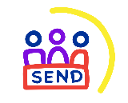 | A group of 15 young people aged 11 to 25 years old with special educational needs and disabilities.  Members serve a 2 year term.  The group meet once a month either online or in person to work on their own campaigns and projects as well as share their views with services. | Outside of education setting | Share the opportunity with students.  Information about the SEND Youth Council can be found here.
Compass House  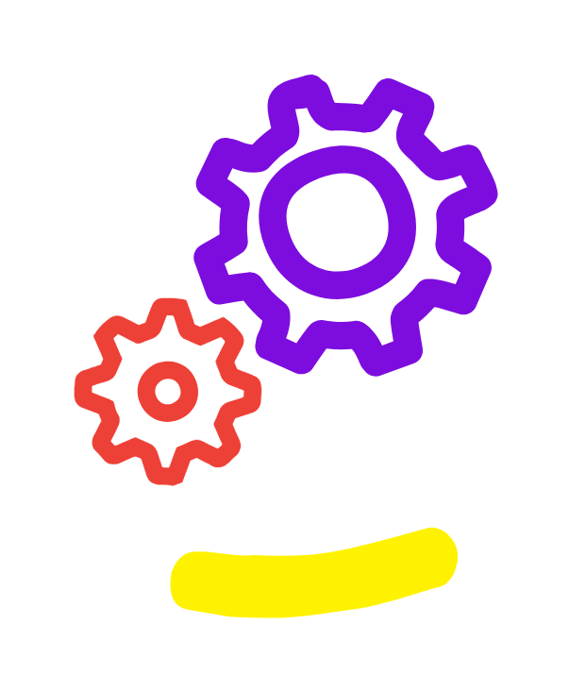 | Compass House is a work experience project for students with SEND in Leeds. Students come together to plan and host a pop up shop, making all the decisions about the shop and creating handmade products to sell. Students meet (with staff support) from September to December each year, and the shop is open for one week during the month of December.  Taking part in the Compass House projects provides students with meaningful work experience as well as gaining skills such as working as a team, organisation, dealing with customers and working with money.  Compass House is available for specialist settings. | September to December | Contact VIC@leeds.gov.uk for more information about how you can get involved.  Information about Compass House can be found here.
Make Your Mark   | Make Your Mark is the largest youth consultation in the UK. Young people 11 to 18 years old are asked to vote for the issues they think should become the national campaigns for young people in the UK – this is a bi-annual ballot and will not take place within the 2024/25 academic year. | February, bi-annually | For more information and to get involved email VIC@leeds.gov.uk
Opportunity | What is involved | When it takes place | How to get involved
Takeover Challenge  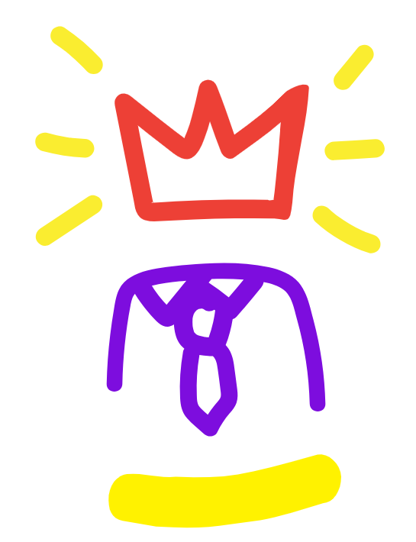 | Takeover Challenge is a national initiative which enables young people to takeover the role of adults during the month of November.  Each year students with SEND are invited to takeover the Leeds Area SEND Partnership Board to speak to them about issues that are important to them. Students gain skills such as planning, team work, public speaking and working with professionals to achieve outcomes. | November | For more information and to get involved email VIC@leeds.gov.uk  Information about Takeover can be found here.
SEND Summit   | The SEND Summit provides an opportunity for students with SEND in Leeds to come together at Leeds Civic Hall to participate in consultations, share their school council successes and learn about services available to them within the city. | February | For more information and to get involved email VIC@leeds.gov.uk  Information about the SEND Summit can be found here.
Democracy Sessions   | The Voice, Influence and Change Team offer 60-minute democracy sessions which can be delivered within the school setting at any point during the school year. The sessions focus on local democracy and introducing young people to voting. | All year round | To request a Democracy Session delivered in your school email VIC@leeds.gov.uk

For more information about our SEND youth voice programmes in schools visit the Leeds Local Offer website or email VIC@leeds.gov.uk

