**Consultation with C&YP and PC 2024**

It is important that Commissioning Team is carefully reviewing the data from the consultation with C&YP and Parents/Carers as well as working with providers and practitioners when commissioning services.

Commissioning Team uses the established Voice, Influence and Change (VIC) networks, Leeds Local Offer site and social media accounts to share information and encourage families to share their views. The networks include a range of parent and carer groups with a SEND focus; young people’s groups; and schools and education settings. Commissioning Team have established relationships with VIC leads in many Leeds schools and settings, who will often support VIC activities with their learners.

As part of this Short Breaks review, Commissioning Team engaged with C&YP, parents and carers by using a mixture of options:

* Focus group with the SEND Youth Forum on 19th October 2023 (via Teams)
* Consultation at the SEND Summit on 14th November 2023 (Leeds Civic Hall)
* C&YP and P/C online surveys (December 2023)

**Feedback from C&YP** (combined responses from face-to-face events and online surveys)

58 C&YP engaged in the consultation and their age range was between 5yr and 18yr (however age of 9 C&YP were unknown).

Initial findings of the consultation highlighted the barriers that C&YP might experience include: “I don’t know what groups and activities there are to do (31); Not having an adult I know with me (21); I cannot get there (20); I am scared or worried to start a new group or activity (20); Not knowing anyone (18); it might be too laud (18); it is indoor/outdoor (5)”.

in addition to the ones considered above, C&YP commented:

* None of the groups are accommodating me.
* There’s a limit for my level of need and age group
* Find activities overwhelming till I am comfortable
* Cost
* Time i.e. too early or too late
* Overnight stay (put off by it)
* Parents are worried about us joining groups
* Lack of understanding of the English language
* Fear of being bullied.

Most of the participants are taking part in activities (Sports, Dance, Music, Youth Groups, Arts and Crafts, Video games, Horse Riding, Gymnastics, Scouts, Brownies, Swimming), 39 out of 58 (67%), and they find out about it mostly through their parents or school, but also friends and websites.

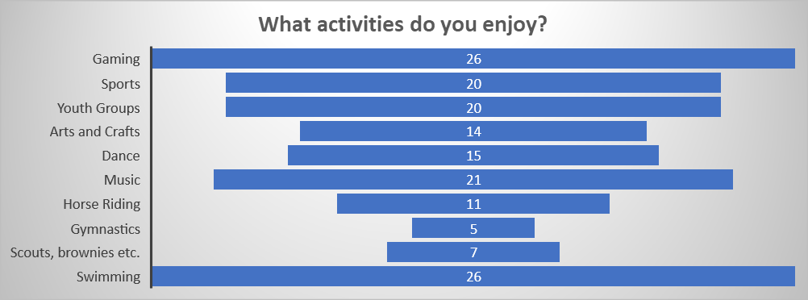

The three things most quoted by C&YP that would make their experience a better one are: Meeting the members of staff first (35), Plan of what will happen during the activity (33), attending tester sessions (33).

Additional comments from C&YP included:

* photo of my staff member
* Preparing the young person for the activity via discussions and reminders
* Activities within walking distance
* Having snacks at an activity
* Come into schools
* Ask questions.

**Feedback from Parents/Carers** (online surveys)

91 Parents/Carers engaged in the consultation and their C&YP age range is between 2yr and 18yr.

Overall, Parents and carers expressed a lot of positive feedback about the Short Breaks provisions in Leeds but also commented on what didn’t work well and made suggestions on how it could be improved (details on the below sessions).

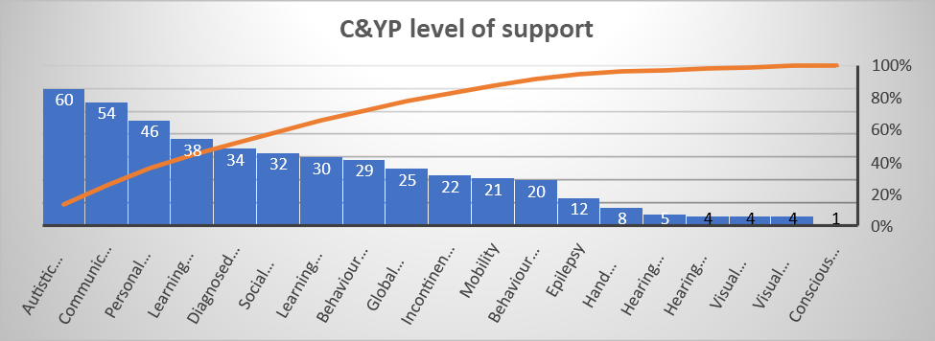

Parents and carers’ additional comments:

* A short break should be something that doesn’t take longer to organise than to execute.
* We don’t do anything as there is nothing that is affordable or available.
* I think the title ‘short breaks’ is misleading.
* I go to many activities with my son which are enjoyable but not a proper break as I have to stay.
* A short break is needed when parent carers are ill or need to work.

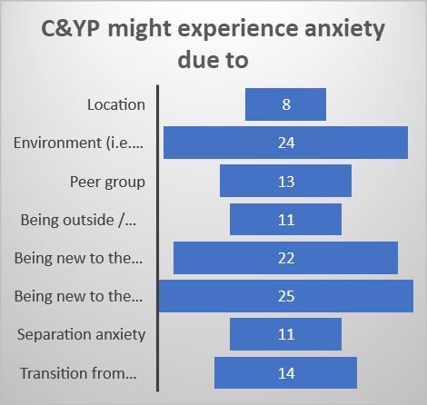

The three most quoted barriers to accessing Universal Short Breaks are staff/volunteers’ skills and knowledge, being welcomed and inclusive, and waiting list.

Majority of C&YP accessing Universal activities had their needs met and enjoyed the activity. However, 44 % of the respondents do not access any Universal activities.

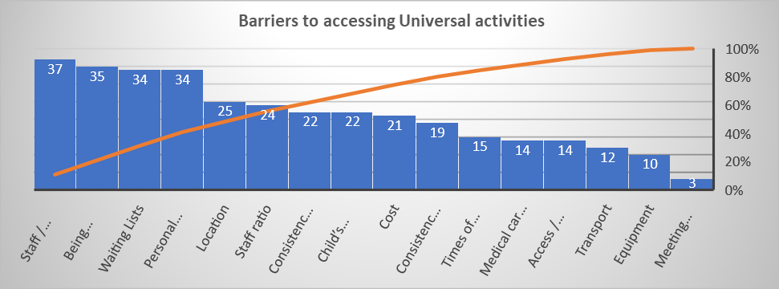

Parents and Carers accessing Targeted Short Breaks and Fun Activities have mostly self-referred their C&YP by either filling the online application form or contacting providers directly, some were referred by a professional and other signposted by schools.

The most quoted barriers to accessing Targeted Short Breaks are waiting list (53), location (30), time of the activities (26), personal care needs (26), cost (25), then followed by the ones listed on the below graph.

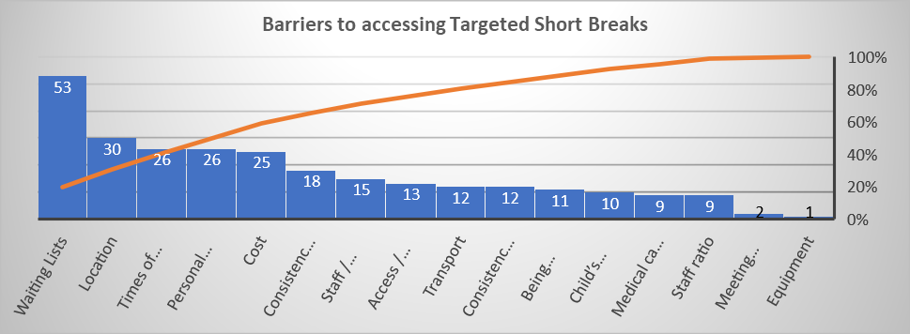

Additional barriers experienced by Parents and Carers include:

* Targeted but not catering for certain needs and no flexibility to use own PA to breach those gaps.
* My child would not like to be just interacting with other SEND children.
* Not many activities for under 8s.
* Not being aware of what is available.
* Having to fill out a separate referral form for each provider.

**“Parents/Carers’ quotes and suggestions”**

What works well **(Targeted)**:

-Communication, reliable staff, friendly face, clear expectations, fun, making friends”.

-They did everything they could to make my child comfortable”.

-Access to therapy and play with other children”.

-Making new friends and trying new things with 1:1 support in a safe space”.

-We worked together to find out what might be triggering anxiety and managed to sort it”.

-Visual timetable sent out before C&YP attend sessions”.

-Support for my child, I got some relax and realised I wasn’t alone”.

What doesn't work well:

-Lack of sufficient staff to manage seizures and not possible to use PA support due to it being a targeted activity.

-Some activities not accessible to wheelchair users with physical needs.

-Children expected to do more for themselves than they are able to.

-It relies on parent carers - it isn’t a break/rest.

-Only a few dates given as oversubscribed.

-Limited and irregular provision causes distress

What worked well **(Specialist):**

-Able to employ their own PA.

-Getting regular breaks.

-Flexibility of a personal budget means they get more support when they need it most.

-C&YP developing independence through PA or ISW support.

-Personal budget works better than direct payments for some as it gives more flexibility.

What didn't work well:

-Recruitment and retention of PAs is hard work/challenging.

-Not enough PAs.

-Having to find replacements regularly since they are often students.

-Not being able to access targeted breaks using PA support.

-The budget is not sufficient to meet C&YP’s needs.

**Parents and Carers asked the Commissioning Team to look at the below suggestions as a way of improving the Short Breaks and Fun Activities provisions in Leeds:**

* Parents of SEND children need holiday provisions so parents can work as there is absolutely nothing suitable and it’s impossible.
* There are not enough short breaks schemes available especially in the summer holidays.
* It is so difficult to find activities to do and gets even harder the older the children are.
* Parents need more than 3hrs a month.
* Parents are grateful that there is being a review held as they feel it needs to be made much clearer about what is out there.
* All universal services should have training in SEND, especially autism.
* One form for accessing all the breaks and a proper process with dates would be great.
* More overnight stays and arranged transport.
* Increase the range of specialist breaks/activities for children with SEND.