**School Aged Immunisation Service Stakeholder Engagement Report**

The NHS England North East and Yorkshire Public Health Programmes Team requested feedback from people who work with School Age Immunisation Services, or have immunisations provided by School Age Immunisation Services, to help understand if the service currently meets the needs of all regional populations and if any improvements could be made. Some of the key findings are covered in this report.

1. **Service Users**

The survey was viewed by 6797 people with 5894 that were happy to consent to their information being stored and processed by NHS England: providing an 87% response rate. Respondents were asked to state their locality; the graph below shows the areas of respondents.

* The survey was shared with LA Education colleagues, SAIS Providers and C&YP Networks across regions to share across any communication mechanisms they could access; no further follow up on how surveys were shared is available. There is wide variation in response rates across localities suggesting communication mechanisms were not far reaching in some localities
* There are 31 Locality Areas across NE&Y Commissioning Region: 16 in North East & North Cumbria and 15 in Yorkshire & Humber
* The eligible populations from both regions:
  + Yorkshire & Humber – 596,647 (64.6%)
  + North East & North Cumbria – 327,153 (35.4%)
* 75% of respondents were from the Yorkshire & Humber Region leaving 25% from the North East & North Cumbria Region.
* A high response rate was seen in North Yorkshire (37.8%), followed by Leeds (20.5%) then Rotherham (7.4%), suggesting the survey was communicated widely using an appropriate mechanism for the population.
* 87% of respondents were age 19 and over, leaving 13% of respondents between the ages of 4 and 18.
* 84% of respondents were parents/carers, 4% of respondents were school staff, and 11% of respondents were school pupils.

**Awareness of School Immunisation Teams**

Survey respondents were asked if they were aware of the local school immunisation team that provide vaccinations in schools in their area.

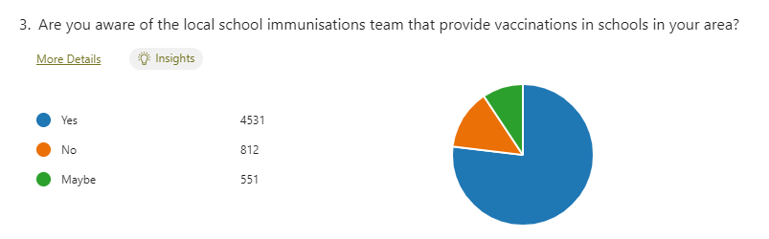Q3. Are you aware of the local school immunisations team that provide vaccinations in schools in your area?

|  |  |  |  |
| --- | --- | --- | --- |
|  | Yes | 4531 | 77% |
|  | No | 812 | 14% |
|  | Maybe | 551 | 9% |

* 77% of respondents answered Yes to being aware of their local immunisation team.
* 14% of respondents answered No to being aware of their local immunisation team.
* 9% of respondents answered Maybe to being aware of their local vaccination team.
* Further investigation highlighted the highest percentage of those who said No, in relation to number of responses were in the 4 – 10 age range (16.99%).

|  |  |  |  |  |  |  |  |
| --- | --- | --- | --- | --- | --- | --- | --- |
| Age | % Maybe | Count Maybe | % No | Count  No | % Yes | Count Yes | Total Count |
| 19 and over | 9.22% | 464 | 13.61% | 685 | 77.17% | 3883 | 5032 |
| Age 11 – 18 student | 10.06% | 52 | 13.54% | 70 | 76.40% | 395 | 517 |
| Age 4 – 10 student | 8.11% | 21 | 16.99% | 44 | 74.90% | 194 | 259 |

Q4. Do you know how to contact your local school immunisation team?



|  |  |  |  |
| --- | --- | --- | --- |
|  | Yes | 1409 | 24% |
|  | No | 3802 | 65% |
|  | Maybe | 683 | 12% |

* 65% of respondents answered No to knowing how to contact their school immunisation team
* 24% of respondents answered Yes to knowing how to contact their school immunisation team
* 12% of respondents answered Maybe to knowing how to contact their school immunisation team
* Further investigation revealed that there was an even spread across all localities of respondents that answered No – average of 65% with a variation of 0% to 85.7%.
* In addition to this, investigation into the age ranges of respondents who answered No also highlighted that this was evenly spread across all age groups. This indicates that a significant increase of awareness is required for all age groups.

|  |  |  |  |  |  |  |  |
| --- | --- | --- | --- | --- | --- | --- | --- |
| Age | % Maybe | Count Maybe | % No | Count  No | % Yes | Count Yes | Total Count |
| 19 and over | 11.74% | 591 | 64.71% | 3256 | 23.55% | 1185 | 5032 |
| Age 11 – 18 student | 11.41% | 59 | 60.73% | 314 | 27.85% | 144 | 517 |
| Age 4 – 10 student | 10.81% | 28 | 66.41% | 172 | 22.78% | 59 | 259 |

Q5. How are you involved in the Immunisation Service for children aged 5-19 or children aged 5-25 with special educational needs and disabilities?



|  |  |  |  |
| --- | --- | --- | --- |
|  | School pupil | 673 | 11% |
|  | School Staff / education stakeholders | 252 | 4% |
|  | Parent/carer | 4952 | 84% |
|  | Young person aged 5-19 not attending school (e.g. home-schooled) | 17 | <1% |

* Most respondents were parents or carers
* Less than 1% of respondents do not attend school e.g. are home schooled

**Children, Young People, Parents and Carers**

A series of questions were aimed at children, young people, parents, and carers to understand responses from people who use the immunisation service separately from those who support the Immunisation Service.

Q6. Tick the emoji which mostly represents your answer to the statements below:

|  |  |
| --- | --- |
|  |  |
| I was aware that school immunisation teams were visiting the school |
| I received information about the vaccinations that were to be delivered |
| I understood what would happen on the day of vaccination |

* Generally, there was a positive response to Q6 with almost 75% of respondents answering that they were aware that the school immunisation team were visiting and received information about the vaccinations to be delivered.
* Of the 5894 respondents that consented to the survey, 416 respondents answered 🙁 to all three statements (7.1%).
* From further investigation into these responses, the most common reason for this was due to a lack of communication and receipt of timely information from schools.
* Other statements were from respondents who do not consent to the vaccines being given.

Q7. If you answered 🙁 to any statements in Q6, please could you suggest how the team could improve the information or the way it is communicated.

There were 1235 responses offering a range of improvements/themes, these included:

* Improved communications – including longer notification time, easily accessible information, use of emails
* Lack of response and more visibility of vaccinating teams
* Awareness of Special Educational Needs – liaise with school nurses
* Advice that vaccination had been received – such as leaflet to parents
* Concerns regarding Covid vaccination more than other childhood vaccinations
* Unsure which vaccinations are to be given – some parents seem to be confused with the amount of information, suggesting communication on vaccination schedules would be helpful

Q8. Please can you tell us how you are made aware of the day you or your child would be vaccinated in school. (You can select more than one if you need to)

* The data above suggests school age immunisation services across the region mainly use Email, Letters, School Communication Portals and Text to communicate information about vaccination dates.

Q9. In relation to Q8 – what is the best method for the school immunisation team to communicate information to you. (You can select more than one if required)

* The responses received from respondents suggest Email is the most preferred method of communication for receipt of vaccination information followed by Text, School Communication Portal and Letter.
* The responses also suggest that schools would need to support school immunisation providers to deliver information across a range of methods.

Q10. The school immunisation team must obtain consent from a parent/carer or a young person who can consent themselves as agreement to receive a vaccination. What would be your preferred method of providing consent to the immunisation team?

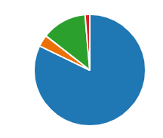

|  |  |  |  |
| --- | --- | --- | --- |
|  | Email with weblink | 4635 | 82% |
|  | Telephone Call | 193 | 3% |
|  | Letter | 737 | 13% |
|  | Other | 77 | 1% |

* Although the data above shows a high percentage of respondents selecting Email with weblink as the preferred method of consent (82%), this information also highlights that there is still a proportion of the population that would prefer a non-electronic method of consent.
* With 13% of respondents answering Letter as their preferred method of consent, this would suggest that there is still a requirement for paper consents across the region.
* 1007 respondents answered Letter, Telephone Call or Other

Q11. If you answered Other to Q10, please could you state your preferred method of providing consent to immunisation.

* Respondents who answered Other suggested using Text messaging, School Communication Portals, Face to Face discussion/informed verbal consent.
* Responses also included those who do not consent.

**School Stakeholders**

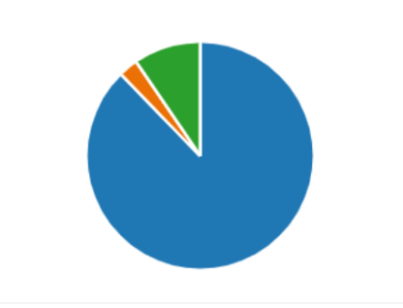Q12. Prior to school immunisation team visits to your school, are you informed of the visit, what vaccinations will be delivered and what would happen at the session?

|  |  |  |  |
| --- | --- | --- | --- |
|  | Yes | 221 | 88% |
|  | No | 7 | 3% |
|  | Maybe | 24 | 10% |

Q13. If you answered No or Maybe to Q12, please can you suggest any changes to improve planning and processes?

* Main themes included: paper consents to be available, receipt of information from school imms teams in more timely manner, better communication, and ways to contact the service, longer deadlines for consent, book dates at beginning of year etc

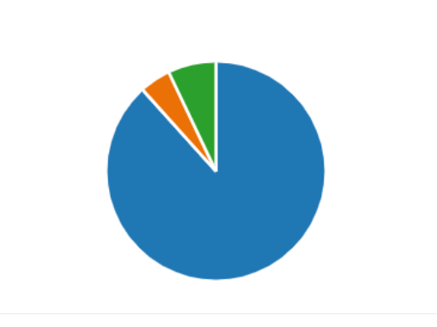Q14. Are you always fully informed of when the school immunisation team will be vaccinating at your school?

|  |  |  |  |
| --- | --- | --- | --- |
|  | Yes | 212 | 88% |
|  | No | 11 | 5% |
|  | Maybe | 17 | 7% |

Q15. How are you made aware that the immunisation team will be vaccinating at your school? (198 responses)

* The most common answer to Q15 was being made aware via Email notification.
* Some responses highlighted that they receive a follow-up phone call from the school immunisation team prior to the visit. This tends to work well as it reinforces the initial email communication.
* Other forms of communication included messages relayed in staff briefings, via secretary staff, and text messages.

Can you suggest any improvements to this process?

* One of the most common suggestions for improvements to this process was for school immunisation teams to have one point of contact to encourage clearer communication.
* Follow up phone call prior to visit would be welcomed.
* Plan year ahead so communication is received in a timely manner.
* Paper consents for families who struggle to read or write/cannot access IT.
* More details around set up, staff arrival, number of staff needs to be communicated as sometimes requires chasing.

Q16. What are the most important things to you in relation to the School Immunisation Service?

Below is a word cloud that displays the most common words/phrases when answering this question.

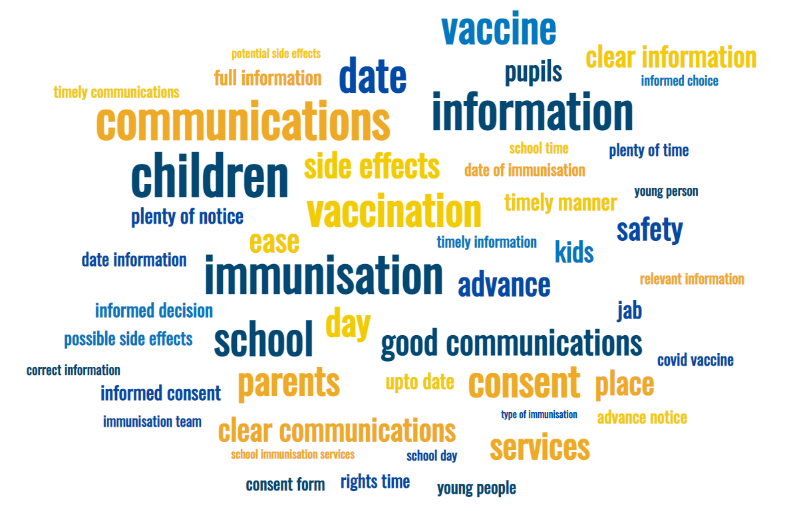

Key themes and ideas were identified as follows:

* Clear, concise communication and information about what is happening and when in a timely manner.
* Advanced notice and receipt of information in a timely manner.
* Clear and well-informed communication on potential side effects and risks.
* Awareness of what is being offered and being fully informed.
* Ensure a kind, empathetic, caring environment is created for the child.
* Safety and protection of the child.
* Timely information and updates to give informed consent.
* Clarity of information, clear and concise information, and communication.
* Convenient and easy consent process.
* Accessibility.

Q17. Do you have any comments on the School Immunisation Service? For example, what works well or anything that could be improved?

Key themes and ideas were identified as follows:

Works well:

* Generally, a highly positive response, working very well across all areas.
* Caring and understanding staff.
* Efficient online consent process, weblink works very well
* Receipt of letter with information regarding potential side effects.

Improvements:

* Card/letter with record of vaccinations for child to bring home.
* Information pack/booklet raising awareness/education of vaccinations, side effects, and myth busting.
* Paper consent – awareness of those who require non-electronic method (this demographic may be missing from this survey due to method of data collection).
* Better overall communication including receipt of timely information.
* More dates/catch up clinics for those who missed.
* Privacy – separate rooms for vaccination.

Q18. What do you think would help more children have immunisations at school?

Below is a word cloud that displays the most common words/phrases when answering this question.

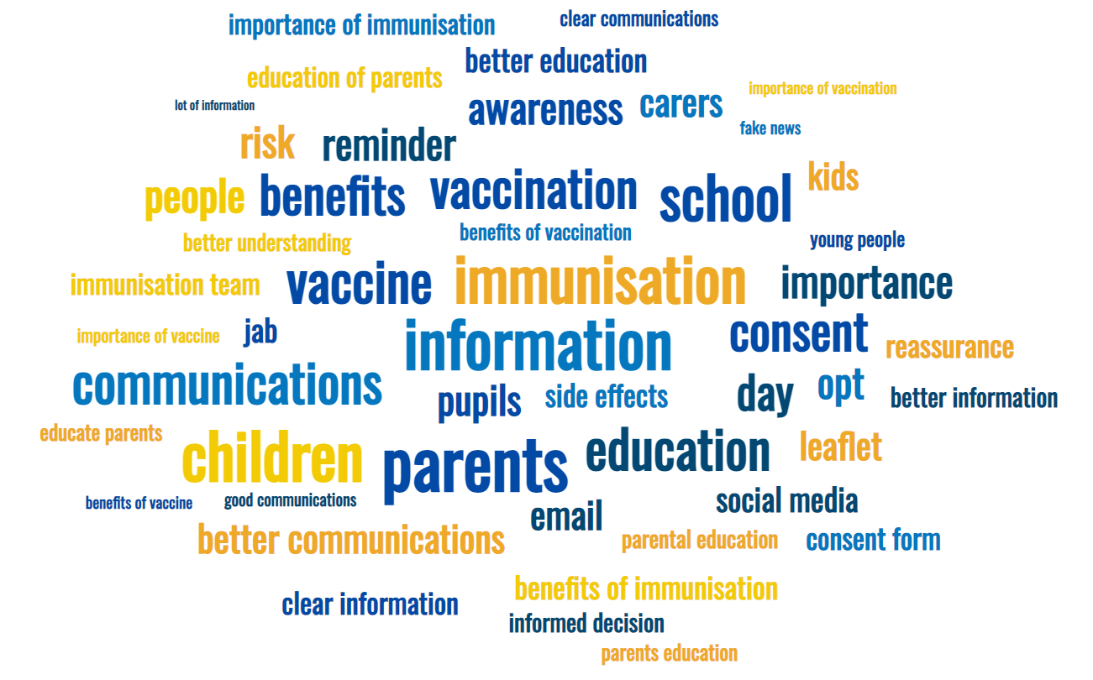

Key themes and ideas were identified as follows:

* Better understanding of the situation for the child – conversation with child prior to vaccination highlighting the need and what will happen.
* Better education for parents – information packs on myth busting, side effects, benefits of vaccination etc.
* Calm and friendly environment.
* Catch up service.
* Small reward/treat following vaccination.
* More awareness in the form of campaigns and advertising.

**Existing Evaluation Insight**

There is some learning and intelligence from previous work in the North East, which has provided insight to support the findings of the stakeholder engagement carried out for the current procurement:

Key findings include:

* Overall, service users had a good experience with the SAIS being respondent to questions that they had. Any information provided was also understandable.
* More work needs to be done to ensure and consider how best that privacy is always provided for children and young people when immunisations are being provided.
* All children, young people and their parents/carers receive appropriate advice regarding immunisations following administration at a session delivered by the SAIS.
* Some work to provide additional information to make it clear to parents and carers and children & young people about the process of vaccination administration when the SAIS is delivering within schools. This includes that information is provided in an appropriate format is provided e.g. consider easy read where necessary.

**2. Wider System Stakeholders**

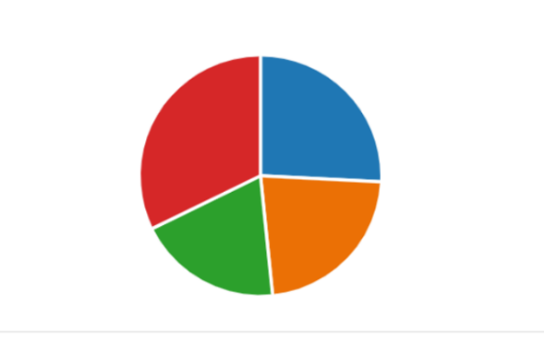Q1. In what capacity are you providing feedback?

|  |  |  |  |
| --- | --- | --- | --- |
|  | Commissioner of related services | 8 | 27% |
|  | Population health lead | 7 | 23% |
|  | Service/cohort expertise | 5 | 17% |
|  | Other | 10 | 33% |

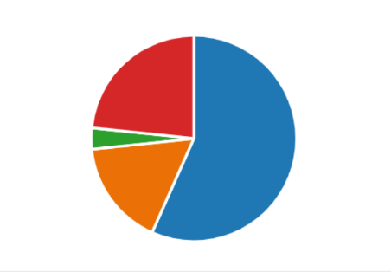Q2. Which of the following best describes your organisation?

|  |  |  |  |
| --- | --- | --- | --- |
|  | Local Authority | 17 | 57% |
|  | ICS/ICB | 5 | 17% |
|  | Third Sector | 1 | 3% |
|  | Other | 7 | 23% |

**Other includes:** Acute and Integrated Trust Provider, Covid Vaccination Service, Covid & Flu Vaccine Lead, GP Practice, Health Worker, Practice Nurse and System Vaccination Operations Lead

Q4. Are there any opportunities to improve pathways, service user experience, or integrated care for school age immunisations, which you think school age immunisation services could address?

* Liaise with school nursing team who offer drop-in sessions/encourage more holistic approach
* Earlier/regular engagement with school leaders
* Allow sufficient time for completion of consent forms
* Service users need to be more informed and more aware of how to contact SAIS
* Both online and paper consent is fundamental
* Importance of point of care live data entry
* Unreliable transfer of data to EMIS practices
* More communication regarding proposed immunisation programme for the year including catch up sessions and contact details
* Standardised approach to improving relationship between SAIS and schools
* Ensure clear links with other vaccination providers
* Education needed for pupils/parents around vaccinations – Personal, social, health and economic (PSHE) / Relationships and Sex Education (RSE) within schools

Q5. Do you have any suggestions about how this service could reduce health inequalities relating to school age immunisations?

* Target areas with lower uptake and provide more options for children who fail to attend – localised drop-in and mobile sessions, catch-up clinics etc
* Opportunities to receive vaccination outside of school or in private setting
* Improve consent processes – more advanced notice, send reminders and paper consent to be available for digitally excluded communities
* Integration as part of the 0-19 service – would ensure added value as the service already has established relationship with service users
* Utilise links with school nursing teams to target specific groups

Q6. How could this service work with primary care and other children’s services to maximise the Making Every Contact Count (MECC) principal?

* Working with school nursing team/local children’s partnership to understand local needs and priorities
* Agree what local priorities are with local public health teams – tailor advice to individual patient groups
* Sharing awareness of planned visits to school can identify timings of local campaigns and sharing of information
* Provide school immunisations in a range of other settings coordinated with health promotion teams and including parents/carers
* Active involvement in partnership forums outside the traditional forums
* Share information regarding any health concerns identified during contact with young people at immunisation services
* Joint promotion between the 0-19 service and SAIS in advance and at the time of delivery

Q7. Is there any further support you, or your organisation, can provide to commissioners and/or providers to support integration of this service, and/or maximise the ability for the service to address health inequalities?

* Meeting with the SAIS termly would provide an opportunity to share the challenges and discuss options for support with addressing issues – could be virtual and even done regionally
* The SAIS needs to be accountable to local place based integrated services
* System Vaccination Operations Centre (SVOC) and the bringing together of Flu and COVID immunisations
* Supporting with communications around community clinics – could offer more support to the SAIS to work with other children’s services to promote immunisations or work with schools to address potential issues
* Shared information and better communication
* Links to key education and inclusion contacts
* Encourage all children to attend for immunisations and stress importance of immunisations when health promotion is delivered in schools
* Commissioning behavioural insights into HPV uptake as our local rates are poor – if we had data about uptake rates by school or LSOA then we would be able to work directly with low uptake schools or with the relevant communities
* The School Nursing service feeds back about issues within schools or the community which could impact on immunisation delivery and adjust the service to meet the need
* Local immunisation inequalities group is a practical way of doing this – would be valuable to include representatives of local authority commissioners of 0-19 services, and those with a good understanding of local set ups in future recommissioning and service development
* Integrated with National Child Measurement Programme (NCMP) / Personal, social, health and economic (PHSE) / audiology service offer in schools
* Would be useful to have a health inclusion team to ensure services are directed to the groups
* Children with Special Educational Needs and Disabilities (SEND) should be offered a more specialised service due to risks around timing of obtaining consent and when they are then offered the immunisation
* A parent/carer should be available for the child/young person with complex needs therefore this may require commissioning of a specialised service which could be delivered in the community where the child or young person may feel more comfortable and it be more accessible too.
* This can be facilitated through local forums within the local areas

Q8. Children who fall within the at-risk cohort are eligible for vaccination within primary care. Special Educational Needs and Disabilities (SEND) schools tend to have a high proportion of children who are within the at-risk cohort, and therefore previously we have asked providers to offer vaccinations to all pupils within primary and secondary SEND schools.

What are your views on whether this provision should be included within the new SAIS service specification?

* There was an overwhelmingly response to this question highlighting that this provision should be included with the new SAIS service specification
* SEND schools should be included within this provision but there must be flexibility for parents/carers to choose a different offer e.g. Primary Care
* Flexible approach between SAIS and Primary Care
* Providing vaccinations within the school environment is better for the child as it causes less disruption to education
* Yes, as it requires specialist input and is favoured by parents – liaise closely with the special school nursing staff

Q9. Are there any other alternative service delivery models for school age immunisation programmes which you think should be considered?

* Clinics across clusters of small schools may be more cost effective
* Delivery through schools during term time should be supplemented with a drop-in provision/catch-up clinic for those not in school or home educated etc
* Joining up of Covid vaccine workforce
* Mass vaccination sites
* Could be delivered as part of wider pathway allowing for parent choice to maximise uptake, especially with inclusion health groups and those with vaccine hesitancy – 0-19 service and Primary Care should be explored
* Return service back to school nursing team
* Linkages to the development of the National Immunisation Service – importance of decentralised Programme Management Office (PMO) for SAIS providers

Q10. Providers have raised challenges with accessing accurate and up to date information about children within eligible cohorts, especially those home-schooled, looked after children, gypsy/roma/traveller communities, refugees.

Are you, or your organisation, able to offer any support for this?

* Specific teams may have this information e.g. school admissions will have home schooled details, Looked After Children (LAC) teams have information on children in their area
* Through System Vaccination Operations Centre (SVOC) and North East Commissioning Support (NECS) this can be reviewed
* Local authorities and place-based services can provide this information – would be beneficial to have a clear and planned ask negotiated ahead of time
* Reliant on local and national data to guide us – engaging directly with the local communities has helped some of this
* Happy to support and make links as appropriate e.g. via Local Authority education, community champions etc
* Collaboration of Local Authority and 0-19 service could work collaboratively with SAIS to support imms uptake in the school aged travelling community – work with LA based-on Traveller and Showmen’s Guild calendar

Q11. Providers have highlighted the importance of SAIS providers working with partner services, creating integrated approaches and pathways with 0-19 children’s services at a local level and looking at shared outcomes from a commissioning/provider delivery perspective.

What are your views on this? Do you have any specific example of the benefits for this, and how important do you think this is?

* 0-19 is delivered in house and already support SAIS where required – would be useful to be involved in shaping the roll out for a programme in any given year to ensure all providers in the system are working to the same goals.
* Developing a joint plan looking at some of the challenges for the service would help identify opportunities to work collaboratively.
* Capacity within all services is limited – 0-19 services would need to be clear what the expectations are of the providers.
* Some 0-19 services offer school drop-in sessions – SAIS could link with this. Also have a prevention bus, so they could link in with opportunities such as this to promote, school-based assemblies etc.
* Having access to all health information in one place is also beneficial as the service can therefore have more impact on uptake where vulnerabilities are known.
* Opportunities to support delivery to housebound patients working with DNT and PCNs to realise efficiencies.
* Concerns about the recent fragmentation of the 0-19 service in general – this used to be fully integrated with named health visitors and school nurses for our patients, but this is disappearing now, and parents do not know who to turn to.
* GPs do not know who is working with families and this has implications for information sharing, safeguarding and continuity of care.
* For asylum seekers- the school nursing service sends a generic letter out to parent/guardian to say vaccinations required/the children in care team have an initial assessment and the task for vaccinations is allocated to the social worker.
* SAIS have limited time to carry out promotion or engagement work – 0-19 service and public health could help with this.
* Nurseries and schools should include immunisation questions on their entrance/application/yearly update of personal information forms to raise awareness of the importance of immunisations and be able to take a proactive approach to encouraging catch up.
* This is essential for driving a successful and improved programme and the spec needs to reflect the time and skills required to do this.

Q12. Are there any other areas where you or your organisation could support the provider and/or commissioner in partnership working or integration of the service?

* Align communications – during the Covid vaccine roll out we set up headteacher briefings for the SAIS, using our public health networks.
* Worked with the CCG to provide a community offer as soon as we understood the uptake from the SAIS.
* Work with our primary care networks to ensure GPs are all aligned to the overall aims.
* Have a vaccine board and a vaccine inequalities group which the SAIS are welcome to participate in. These groups have CCG, GPs, pharmacy, the Voluntary and Community Sector (VCS), NHSE etc all represented.
* Working closely with the provider as well as NHSE to improve the way we work together and to support the provider as much as possible.
* As public health working within the local authority we can support with communications, data, system links, organising venues and facilitating contacts with schools and community groups.
* Putting significant resource into facilitating a multi-agency working group to improve uptake and via this route are happy to signpost/share resources as required; indeed, we have already offered huge amounts of support to the provider.

Q13. Are there any other risks or issues associated with the service model, other than those identified already, which you could foresee. Please include brief details of potential impact and any proposed mitigating actions for commissioners or providers.

* Schools have fed back that it is sometimes difficult to have access in advance of the service risk assessments and delivery plans
* Impact of Flu and COVID this winter impacting on NHS workforce and preventing NHS recovery therefore upskilling 0-19, SAIS for COVID would provide System resilience.
* Lack of integration, fragmentation, data loss, clients marginalised when unknown to partners. Integration with a single provider which is part of the acute & community trust coterminous with Local Authority boundaries would overcome these difficulties.
* In terms of risk, the inclusion of secondary school age pupils in the flu programme (although good from a health protection point of view) does mean additional pressures on the service that perhaps need to be addressed if this is going to be something they do every autumn/winter.
* In terms of issues, the lack of flexibility around the numbers of community clinics and the hours these run for (within working hours as opposed to evenings or weekends) is an issue for families – particularly those who may be working long hours or two jobs.
* The cost of living crisis also needs to be considered when clinics are arranged as the venues might be inaccessible or too expensive to get to for parents with young children.
* Limited capacity to respond to unforeseen e.g. pandemic or outbreaks.
* Not engaged with local commissioners and priorities – unable to understand the information we have and how this would be of benefit to SAIS.
* There is a risk of discounting the needs of inclusion health populations and delaying the vaccination health intervention for individuals due to a one-size-fits-most model with poor and untimely mop-up and alternative offers.
* Information sharing between SAIS, School Nursing, GP, and CHIS can be delayed therefore contemporaneous information around imms status can be a potential risk.
* Closer communication pathways would help mitigate some of this and enable to offer support when required.
* SAIS is currently under-resourced and requires appropriate resource to work effectively. Also require IT solutions that provide data entry at point of care.
* Greater performance management/holding to account of providers and their approaches to tackling inequalities

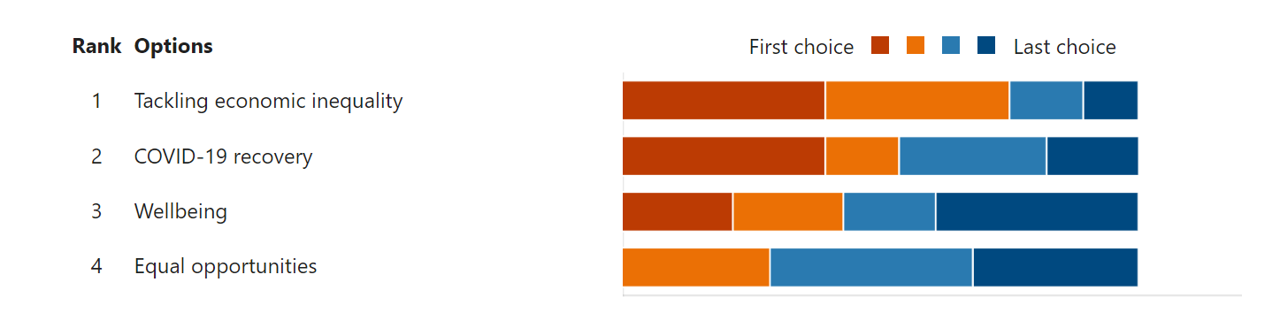Q14.With the remaining four Themes of Social Value, please can you indicate which of these you think also should be assigned a share of the 10% (rank in order with most important at the top and least important at the bottom).

Below are a range of follow up comments in response to Q14:

* The continued impact of Covid has an impact on the remainder of the themes
* Inequalities by socioeconomic deprivation are the biggest risk, followed by people with SEND / Learning Disabilities (LD) not being vaccinated
* Economic inequality is the most enduring issue and it continues to be so
* They overlap – anything you do to address inequality will tackle Covid impact
* The issues require change at a strategic level – action is needed to address inequalities and mitigate the significant risk of outbreaks
* The school nursing service are key to looking at the challenges of promoting health messages to those home schooled – joined up partnership work with SAIS teams and community hubs/groups would strengthen this further
* [We] already have significant strengths working in partnerships with agencies to support refugees, asylum seeking families, could be extended into SAIS teams. This lies with the SAIS team being more accessible to strategic delivery of their model and improved communications
* Commissioning arrangements and considerations for the 0-19 service and SAIS teams need to be aligned

**3. Child Health Information System (CHIS) Manager Engagement**

* Majority reported ‘Excellent’ or ‘Very Good’ working relationship with SAIS. The most common reason for this was because they are located under the same organisation and management structure. This supports good communication, data sharing and streamlining processes.
* On average, CHIS Managers reported interacting/working with SAIS daily. This is usually due to working closely within the same organisation.
* CHIS Managers reported good communication with SAIS, however, did highlight how it can be difficult to contact SAIS – may need option of a dedicated phoneline/one point of contact that they can use. Currently have one phoneline that is also used by parents/carers.
* Can be difficult to contact SAIS as clinical members of staff are usually vaccinating.
* Overall, communication between the two organisations is excellent. Strong level of understanding of what each organisation does which is important.
* Main issues involve data flow – receiving data back from SAIS which can mean child records are not updated in a timely manner.
* Occasions when data is sent late, not sent at all, or there is inaccurate or missing data.
* Not proactive at finding new schools if children have moved out of the area – do not chase missing children.