Mental Capacity

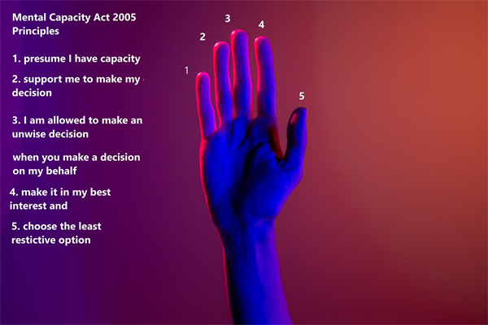

The Mental Capacity Act ( MCA)  has been in force since 2007 and applies to England and Wales. The primary purpose of the MCA is to promote and safeguard decision-making within a legal framework.   
  
It does this in two ways:  
  
By empowering people to make decisions for themselves wherever possible, and by protecting people who lack capacity by providing a flexible framework that places individuals at the heart of the decision-making process  
  
By allowing people to plan ahead for a time in the future when they might lack the capacity.

**Key Messages**  
  
As young people develop, they should be involved more and more closely in decisions about their own future.

After compulsory school age (the end of the academic year in which they turn 16) children become young people and take their own responsibility for engaging in decision making with their education provider and, where they have an EHC plan, with the local authority and other agencies.  
  
Settings have a vital role in supporting young people to make decisions and take control of their own future. It is essential that parents are well prepared for these changes and supported to allow their child’s voice to be heard at the centre of the conversation.   
  
Educational providers should continue to involve parents in discussions about the young person’s future. In focusing discussions around the individual young person, parents, carers and professionals should support that young person to communicate their needs and aspirations and to make decisions which are most likely to lead to good outcomes for them, involving the family in most cases.   
  
It is key that the young person’s aspirations are at the centre of the conversation.   
  
The underlying principle of the MCA is to ensure that those who lack capacity are empowered to make as many decisions as possible for themselves and that any decision made or action taken on their behalf is done so in their best interests.  
  
Decisions about mental capacity are made on an individual basis and may vary according to the nature of the decision itself. Someone who may lack capacity to make a decision in one area of their life may be able to do so in another, for example employment opportunities.

Where a young person has difficulty being involved, a family member, friend, advocate, or appropriate professional may support.  
  
**What is Advocacy for young people?**  
  
Advocacy is about speaking up for children and young people and helping them take part in decisions that affect their lives. It involves making sure their rights are respected, and their views and wishes are heard and acted upon by decisionmakers.  
  
If you are working with a young person who has difficulties with speaking up for themselves, an Advocate can help. Advocates are professionally trained, fair and impartial, and their service is completely confidential and independent.  
  
Advocates support people to:  
  
Develop the skills, confidence, and knowledge they need to voice their concerns and make sure they are being treated right.

Access information and services

Explore choices and options