
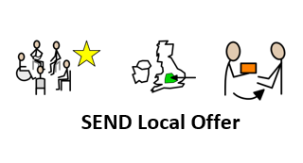

Redesign of the SEND Leeds Local Offer Website
November 2020

What is the SEND Leeds Local Offer?
The Leeds Local Offer website (http://www.leedslocaloffer.org.uk/) if for those 0-25 years old with SEND and has been operational since 1 September 2014.

The Leeds Local Offer is not just a directory of services, it is the unique place where young people with special educational needs and disabilities (SEND) and their families can provide suggestions for improving services and for new services they need. Comments that come in through the website and to llo@leeds.gov.uk can drive and influence service improvement.

Leeds City Council must respond to all feedback and comments received about the Local Offer on an annual basis, and outline what actions have been taken in response to the comments received.

SEND Leeds Local Offer Redesign
The SEND Ofsted Inspection in 2016 highlighted

- Only a few of the parents to whom inspectors spoke were aware of the local offer. Those who know about the web-based information are involved in working with the local area to improve the website. Records show that very few parents use the independent advice and support service. Parents describe both feeling isolated and benefiting from the support networks created by schools and settings.

- Nearly all of the parents that inspectors spoke to during the inspection did not know of, or use, the Leeds local offer. This means that they miss out on key services or do not know where to get high-quality support. The feedback from a small number of parents in August 2016 is being acted on by leaders. Some parents, through the EPIC (empowering parents, improving choices) parents forum, remain involved in improving the offer.

The Local Authority received £15,000 to develop the Leeds Local Offer website in June 2020 based on the need to develop the website so it meets the needs of the users and to promote the Leeds Local Offer to families and professionals.

To ensure the website meets the needs of all (children, young people, parents, carers and professionals) the decision was taken to split the website into three sections:
- I am a child / young person
- I am a parent / carer
- I am a professional

Three online surveys were developed to enable users to give their feedback and feed into the redesign of the website
- children and young people: 9 responses
- parents and carers: 83 responses
- professionals: 28 responses

Children & Young People’s feedback
How do you find out about things to do / where do you go for information?
The young people who responded to the survey primarily find out information from the internet and social media.

Websites young people like to use
All the websites the young people like to use are interactive and video / photo based.

The young people like the websites as they are ‘fun to use’, ‘entertaining’, ‘interactive’ and ‘they are simple to use’.

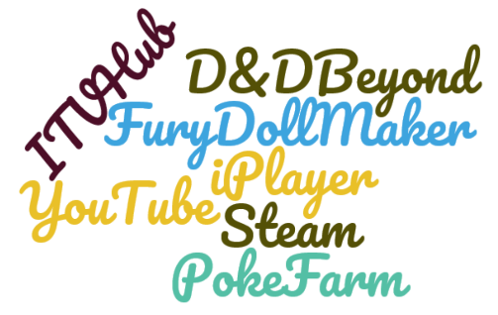

What colour background should we use on the website?
- Blue 8 responses
- Green 2 responses
- Orange 1 response
- Yellow 0 responses

How wold you like to see information on the website?
Young people specifically express they like videos with a short paragraph explaining what it is.

What information would you like to find out about from the Leeds Local Offer?
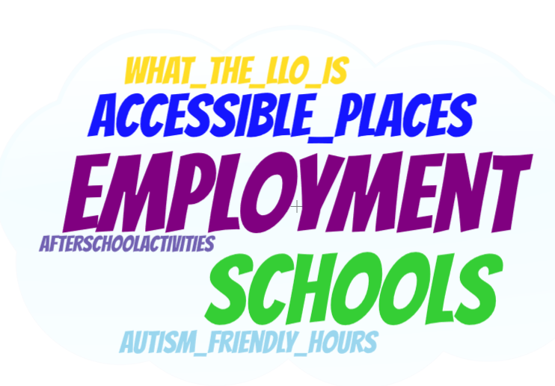

Parents and Carers Feedback
46 parents and carers expressed an interest in being part of the usability of the new website.

Have you heard of the Leeds Local Offer?
The majority of the parents / carers who completed the survey hadn’t heard of the Leeds Local Offer. Those that had heard of it said they found out form:
- Council Officers
- Work
- School
- Services and support groups
- EPIC Leeds

Using the Leeds Local Offer website
The majority of the parents / carers who completed the survey fedback that they hadn’t used the Leeds Local Offer website.

Feedback about the current website:
- Difficult to navigate and isn’t user friendly
- Links don’t work
- Not easy to use or fit for purpose

What colour background should we use on the website?
- Blue 29 responses
- Green 21 responses
- Yellow 19 responses
- Orange 9 responses

Categorising information on the Leeds Local Offer
Parents and carers fedback they would like information categorised by age, service and disability equally as long the website is easy to navigate.

Website search facility
Parents and carers fedback that their preferred website searches would include by age, disability and postcode.

Service summary information
Parents / carers would like to know about the service, targeted age, location and targeted disability on the Leeds Local Offer website before being directed to the services webpage.

Parents/carers also suggested it would be beneficial to have family reviews about services.

Films on the Leeds Local Offer website
As part of the funding received four films will be developed about services, the films will feature on the Leeds Local Offer website.

The four films with the most votes were:
- Education Health and Care Plans
- SENDIASS
- Post 16 Options
- Short Breaks

Information available to families on the Leeds Local Offer
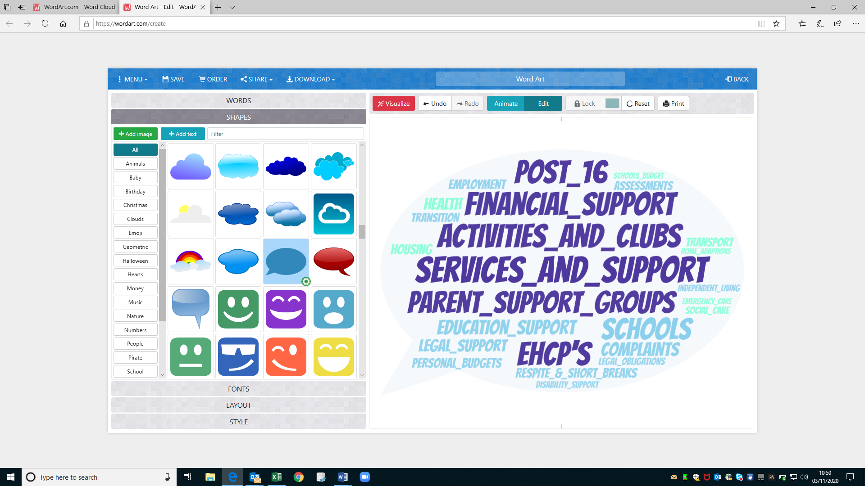

Publicising the Leeds Local Offer
Parents and carers primarily find information via facebook, schools and parent support groups.

Others suggestions to publicise the Leeds Local Offer were:
- Google search
- Twitter / Instagram
- Services
- TV / Newspapers

Professionals Feedback
13 professionals who completed the survey registered to be part of the Leeds Local Offer network.

Have you heard of the Leeds Local Offer?
All but two professionals who completed the survey had heard of the Leeds Local Offer website.

60% of professionals who completed the survey hadn’t used the Leeds Local Offer website, the 17% of professionals who had used the website fedback:
- Information is not easy to find
- Parents find it hard to use
- It is good to have all the information in one place
- The information on the website needs reviewing and updating
- The website needs photos, videos and symbols to help families understand the information
- The website isn’t easy to navigate

What colour background should we use on the website?
- Blue 14 responses
- Yellow 6 responses
- Orange 4 responses
- Green 3 responses

Categorising the information on the Leeds Local Offer
The feedback received from professionals is to have the information categorised by service area i.e. health, education, social care, leisure

Website search facility
Professionals would like to be able to use the search facility to search for services based on age and disability.

Service summary information
Professionals would like to know about the service including the targeted disability as well as the contact details for the service before being redirected to their website.

Films on the Leeds Local Offer website
As part of the funding received four films will be developed about services, the films will feature on the Leeds Local Offer website.

The four films with the most votes were:
- Education Health and Care Plans
- SENDIASS
- Short Breaks
- Post 16 Options

Information available to families on the Leeds Local Offer
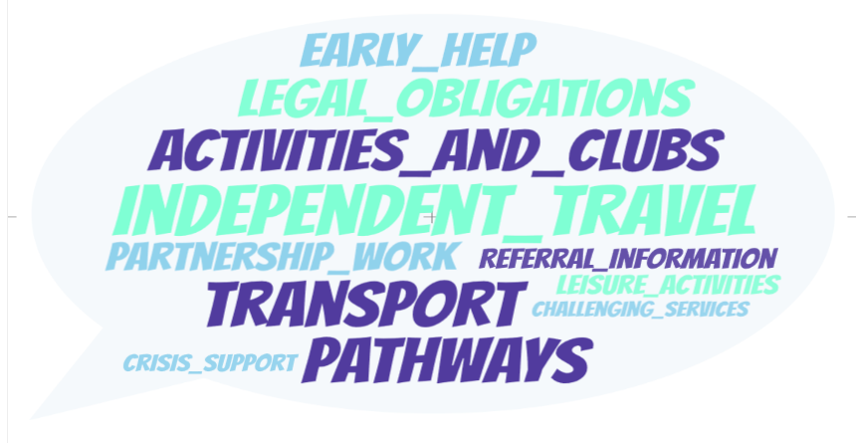

Publicising the Leeds Local Offer
Professionals fedback that the best way to publicise the Leeds Local Offer would be via Facebook, Schools and parent / carers support groups.

Other suggestions made were:
- Links on service websites
- Via entry point services
- Video introductions

What next?
The Leeds Local Offer website will be redesigned and relaunched early 2020.

- All service links will be reviewed and updated

- Develop a Leeds Local Offer facebook page

- Video explaining what the Leeds Local Offer is

- The website will have a blue background

- Symbols and images will be used throughout the website

- Search facility using age, disability and postcode

- Service Information: service description, age, location and disability
Films
- Education Health and Care Plan
- SENDIASS
- Post 16
- Short Breaks

- The Leeds Local Offer will be relaunched early 2020 and will be publicised via Facebook, school and parent / carer support groups

- Postcodes and flyers will be provided to key services so they can promote the Leeds Local Offer website

Children & Young People’s Section
Information will be presented using videos and short amounts of text

Information will be available about
- Schools (resourced, primary & secondary)
- Leisure Activities
- Accessible venues
- Post 16 opportunities

Parents / Carers Section
Information will be categorised by service area using age and disability as subcategories

Information will be available about:
- Financial Support
- Activities
- Post 16
- Support Groups
- EHCP’s
- Schools

Professionals Section
Information will be categorised by service area e.g. health, social care, education

A full list of legal obligations for services will be available directly on the website

